TERRAFORM PROJECT

**TERRAFORM:**

Terraform is a powerful tool used to automate and manage infrastructure. Think of it as a blueprint creator for your digital resources. Instead of manually setting up servers, databases, or networks, you write down what you need in simple, human-readable code. Terraform then takes care of building, changing, or tearing down those resources for you.

Here’s another way to think about it:

* Imagine you're planning a house. Instead of building it brick by brick, you write down your plan, like “I want three bedrooms, two bathrooms, and a garden.” Terraform takes that plan and works with your cloud provider (like AWS, Azure, or Google Cloud) to construct your house (infrastructure) exactly as described.

With Terraform:

* You **write** your infrastructure plan in a code file.
* Terraform **reads** that code and tells you what it will build or modify.
* It then **executes** the plan to create or update the resources.

Since everything is in code, you can save it, share it, and reuse it, making it a reliable and efficient way to manage infrastructure.

### KEY FEATURES OF TERRAFORM:

### 1. ****Infrastructure as Code (IaC)****

* Terraform allows you to define your infrastructure in simple configuration files (written in HCL or JSON).
* These files act like blueprints, making it easy to track changes using version control tools like Git.
* Teams can collaborate effectively by sharing and updating the same configuration files.

### 2. ****Provider Ecosystem****

* Terraform supports multiple cloud providers like AWS, Azure, and Google Cloud, along with other platforms such as Kubernetes, GitHub, and more.
* It can manage resources in both cloud and on-premises environments, giving you flexibility to work with diverse setups.

### 3. ****Resource Management****

* You can define a variety of resources, such as virtual machines, databases, storage, and networks, in the configuration.
* Terraform ensures that your resources are created, updated, or deleted as per your configuration files, keeping your infrastructure consistent.

### 4. ****Execution Plans****

* Before making any changes, Terraform generates an **execution plan**.
* This plan outlines what Terraform will do (e.g., which resources will be added, updated, or removed).
* Reviewing this plan helps prevent unintended changes to your infrastructure.

Terraform simplifies and automates infrastructure management, saving time and reducing human errors.

### COMMON USE CASES:

* **Provisioning Cloud Resources**: Automate the setup of virtual machines, storage, databases, and networking in cloud environments.
* **Multi-Cloud Deployment**: Manage resources across multiple cloud providers from a single configuration file.
* **Infrastructure Automation:** Streamline the process of infrastructure updates, scaling, and configuration management.
* **Collaboration and Versioning:** Use version control systems (like Git) to track changes in infrastructure configurations.

# Terraform - infrastructure:

├── vars.tf

├── vpc.tf

├── subnet.tf

├── route_table.tf

├── web_sg.tf

├── database_sg.tf

├── ec2.tf

├── alb.tf

├── rds.tf

├── outputs.tf

└── data.sh

# TERRAFORM COMMANDS:

### 1. terraform init

* **Why use it?**  
  This command initializes the Terraform working directory.
  + It downloads the necessary provider plugins (e.g., AWS, Azure).
  + Sets up the backend for storing state files.
* **When to use it?**  
  Run this before performing any other Terraform operations in a new or existing configuration directory.

### 2. terraform validate

* **Why use it?**  
  This command checks the syntax and configuration of your .tf files to ensure they are correct.
  + Identifies errors or typos in your configuration.
  + Ensures the configuration adheres to Terraform's rules.
* **When to use it?**  
  After writing or updating your configuration files to verify correctness before creating resources.

### 3. terraform plan

* **Why use it?**  
  This command generates an execution plan, showing what changes Terraform will make to your infrastructure.
  + Lists resources to be added, modified, or destroyed.
  + Helps avoid unintended changes by allowing review before execution.
* **When to use it?**  
  Before applying changes to your infrastructure to understand and approve the impact.

### 4. terraform apply

* **Why use it?**  
  This command executes the changes outlined in the plan to provision or update your infrastructure.
  + Creates, updates, or deletes resources as specified in the configuration files.
  + Requires confirmation unless auto-approve is specified.
* **When to use it?**  
  After reviewing and approving the plan to make actual changes to the infrastructure.

### 5. terraform destroy

* **Why use it?**  
  This command destroys all infrastructure resources managed by Terraform.
  + Used for cleanup or decommissioning environments.
  + Ensures all resources defined in your Terraform configuration are removed.
* **When to use it?**  
  When you no longer need the infrastructure or are transitioning to a different environment.

First step we need to create one instance using own configuration, On the EC2 Dashboard, click **Launch Instance**. Enter a name for your instance .

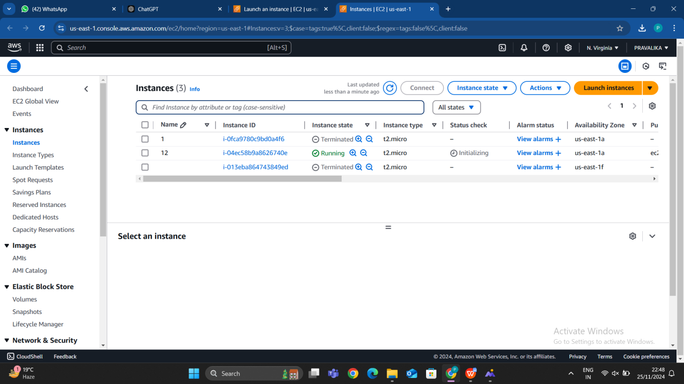

Choose an operating system for your instance, such as Amazon Linux, Ubuntu, or Windows Server based on our preference I have taken an amazon Linux, Select a free-tier eligible. Pick an instance type based on your requirements. For basic usage, choose **t2.micro**, which is free-tier eligible.

Select a key pair name if u don’t have an key pair we have one option on the right hand side click on that and create a new key pair. I already have one key pair so I selected that key pair.

After configuring all the configurations then click on the launch instance

After creating an instance click on that instance in detail section we can able to see the public ip copy that public IP and open PuTTY. We can able to see basic option session of PuTTY in that we need to provide and Public IP or DNS of an instance.

After providing an public IP, we need to click on SSH we can able to see in the left side after that we can able to see Auth clicking on that we can able to see the credentials after clicking on that we need to provide .ppk file click on browse option directly it will navigate to the folder where we have saved .pk file select that file it directly open one terminal.

Click on accept button that shown in above page. We need to login as a ec2-user if we select amazon linux2 AMI, We need to login as based on our configuration of AMI.

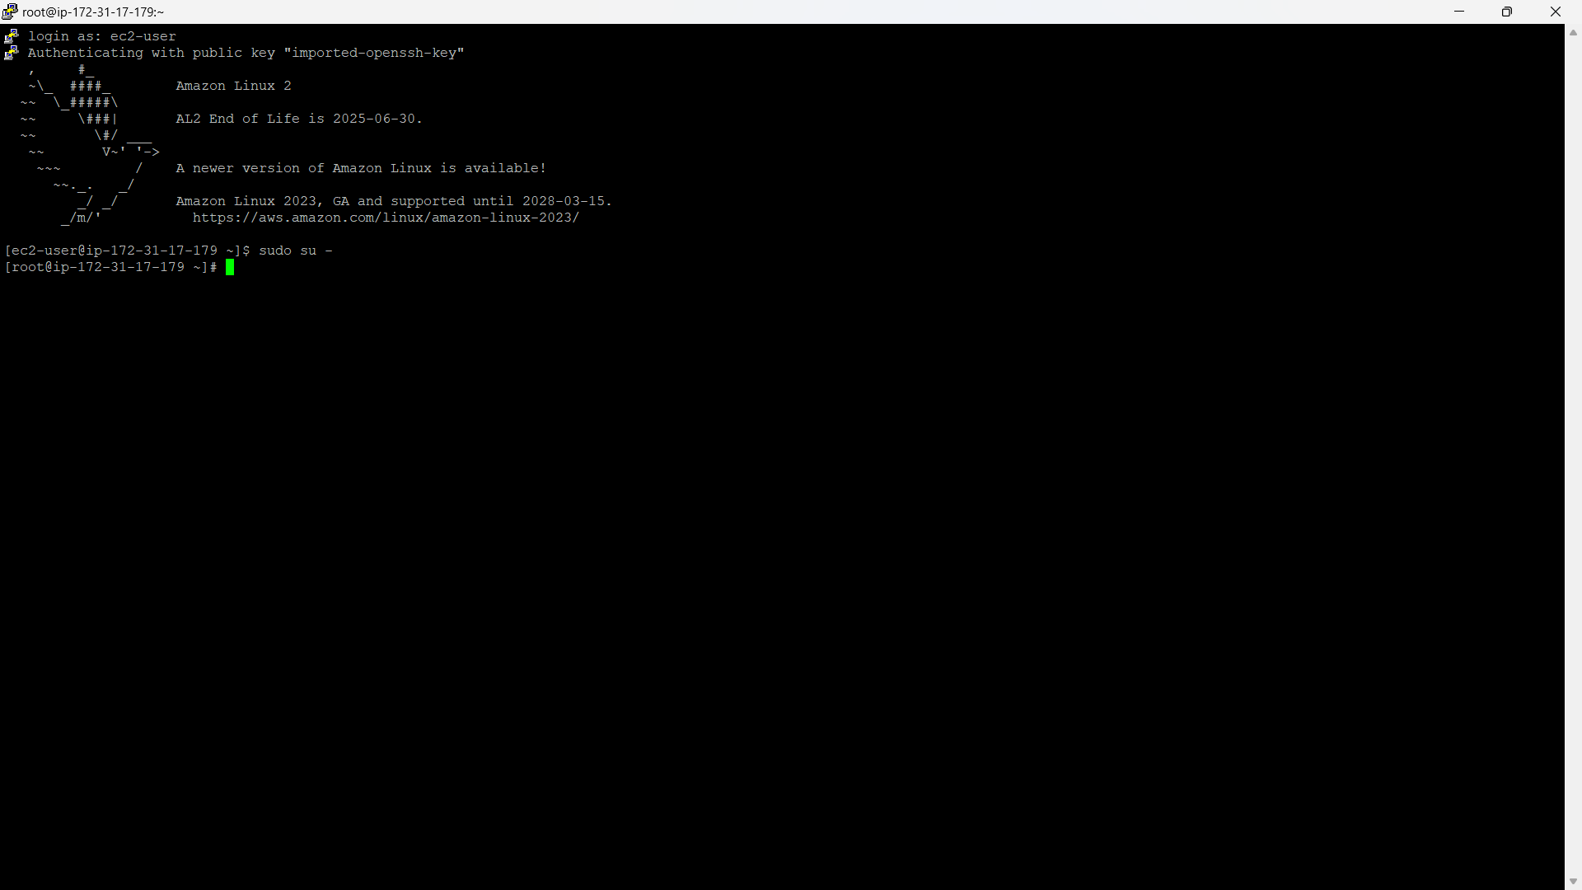

**STEP 1: CREATE A VARIABLES**

In Terraform, **variables** are used to make your configuration more flexible and reusable. Instead of hardcoding values directly into your configuration files, you define variables and then pass values for those variables when running Terraform commands.

Variables allow you to:

* Reuse Terraform configurations across different environments (e.g., development, staging, production).
* Parameterize resources like instance sizes, regions, and security settings.
* Make the configuration more readable and manageable.

If we want to create an any file first we need to install an terraform in our local machine so for that we need to visit an official website as sown in below.

Go to that website and click on amazon Linux as shown in below image click on that we can able to see some commands run that commands in the terminal and terraform has been installed successfully.

## C:/Users/ASUSṆ/Pictures/Screenshots/Screenshot 2024-11-25 231327.pngScreenshot 2024-11-25 231327

## In the below image we can able to see that the downloading process of the terraform.

## 

## 

## In the below image we can able to see that terraform installation completed successfully.

## 

## Keeps your configuration clean and organized. We need to create a variables file vars.tf which allows us to update values in one place without changing multiple files. Makes it easier to reuse configurations for different environments This setup makes our Terraform setup flexible and manageable, especially for large projects.

## Screenshot 2024-11-25 222438

## After that we need to initiate the terraform then we need to run the vars.tf using terraform plan.after that we need to apply it using terraform apply command

**STEP 2: CREATING A FILE FOR VPC**

### Interacting with AWS Using Terraform: Setting Up Key Files

### ****1.**** provider.tf ****File: Connecting Terraform to AWS****

* The provider.tf file defines AWS as the provider and specifies the access credentials required to interact with your AWS account.
* It acts as a bridge between Terraform and AWS, enabling Terraform to manage AWS resources.

#### **Best Practice:**

* Avoid hardcoding credentials directly into the file, as this is insecure.
* Use **environment variables** or **AWS CLI credentials** for authentication instead.

#### Example:

provider "aws" {

region = "us-east-1"

}

After setting up your credentials using the AWS CLI (e.g., aws configure), Terraform can securely access your AWS account.

### ****2.**** vpc.tf ****File: Defining the VPC****

The vpc.tf file contains the configuration for creating a Virtual Private Cloud (VPC) in AWS.

#### **Key Elements of the VPC Script:**

**Resource Type:**

* 1. The resource type aws_vpc is used to specify a VPC.
  2. A logical name (e.g., demovpc) is assigned for reference in Terraform.

**CIDR Block:**

* 1. The cidr_block defines the range of IP addresses for the VPC (e.g., "10.0.0.0/16").
  2. The value can be dynamically passed as a variable (e.g., var.vpc_cidr) to make the configuration flexible.

**Instance Tenancy:**

* 1. instance_tenancy is set to "default", meaning EC2 instances in this VPC share hardware with other AWS customers by default.

**Tags:**

* 1. Tags help identify the VPC in the AWS Management Console. For instance, assigning the name **Demo VPC** makes it easier to manage.

#### Example Script:

resource "aws_vpc" "demovpc" {

cidr_block = var.vpc_cidr

instance_tenancy = "default"

tags = {

Name = "Demo VPC"

}

}

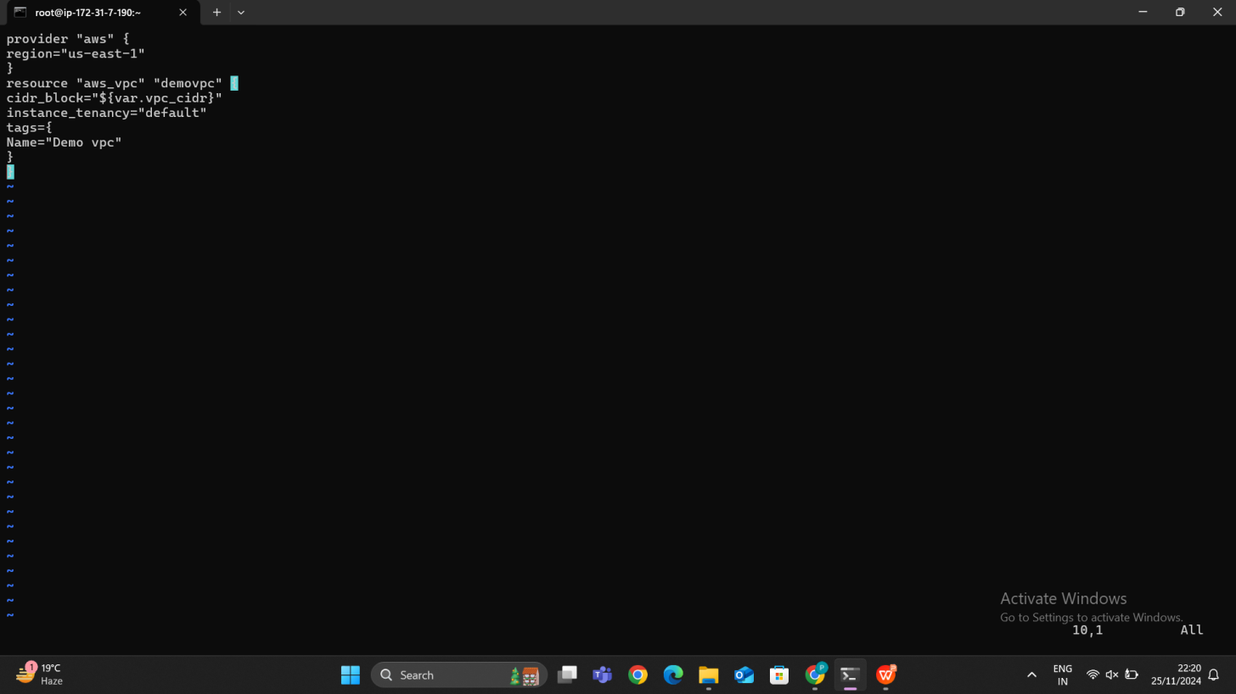

After creating an vpc.tf file then we need to run the **terraform plan** command because the terraform plan command is used to preview the changes in Terraform will make to your infrastructure. It shows you what will be added, modified, or deleted based on your Terraform configuration files, without actually making any changes where Terraform tells you what it's about to do, and you can check if everything looks good before applying the changes within the file before applying changes.

After running an **terraform plan** the below process will be run**.** Then we need to run **terraform apply** then that can be applied.

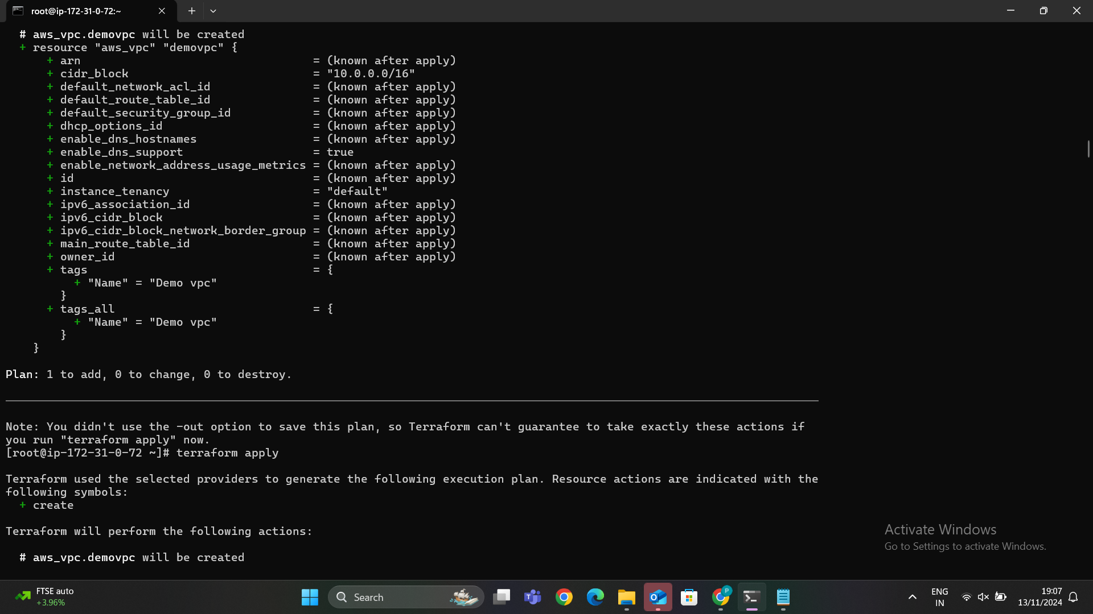

In the below image we can able to see the terraform apply has been completed successfully then go to the AWS account and check we can able to see VPC has been created successfully in our AWS account.

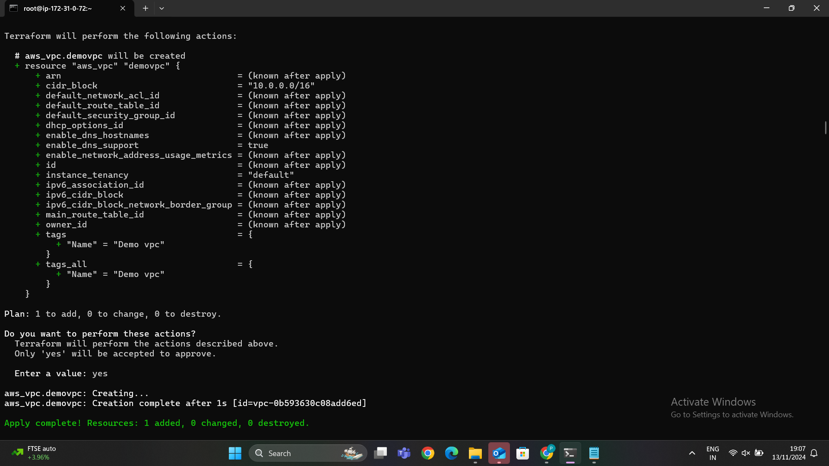

In the below image we can able to see that newly created VPC has been created.

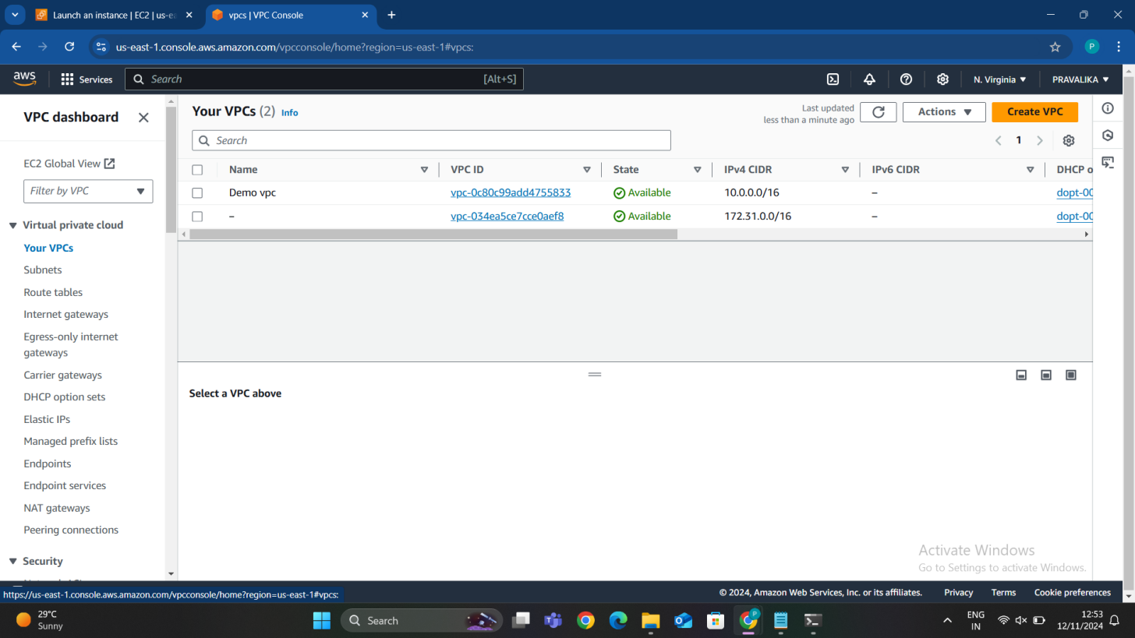

## STEP 3: CREATING A FILE FOR SUBNETS

A **subnet** (short for "subnetwork") is a segment of a **Virtual Private Cloud (VPC)** network that allows you to group resources based on security and operational needs. Subnets help divide a VPC into smaller, more manageable chunks, each with its own range of IP addresses. You can assign AWS resources such as EC2 instances, databases, and load balancers to a subnet within your VPC.

There are two main types of subnets in AWS:

1. **Public Subnets**: These subnets are connected to the internet and can have resources that need to be publicly accessible (e.g., web servers, load balancers).
2. **Private Subnets**: These subnets are isolated from the internet and typically contain internal resources that don’t need direct access to the internet (e.g., databases, backend application servers).

After creating the VPC, the next step is to create subnets within that VPC. I have created **subnet.tf** file for Subnets allow you to organize your network into smaller sections, each with its own CIDR block. I have created 6 subnets for an existing VPC. The subnet is linked to an existing VPC by specifying the vpc_id.

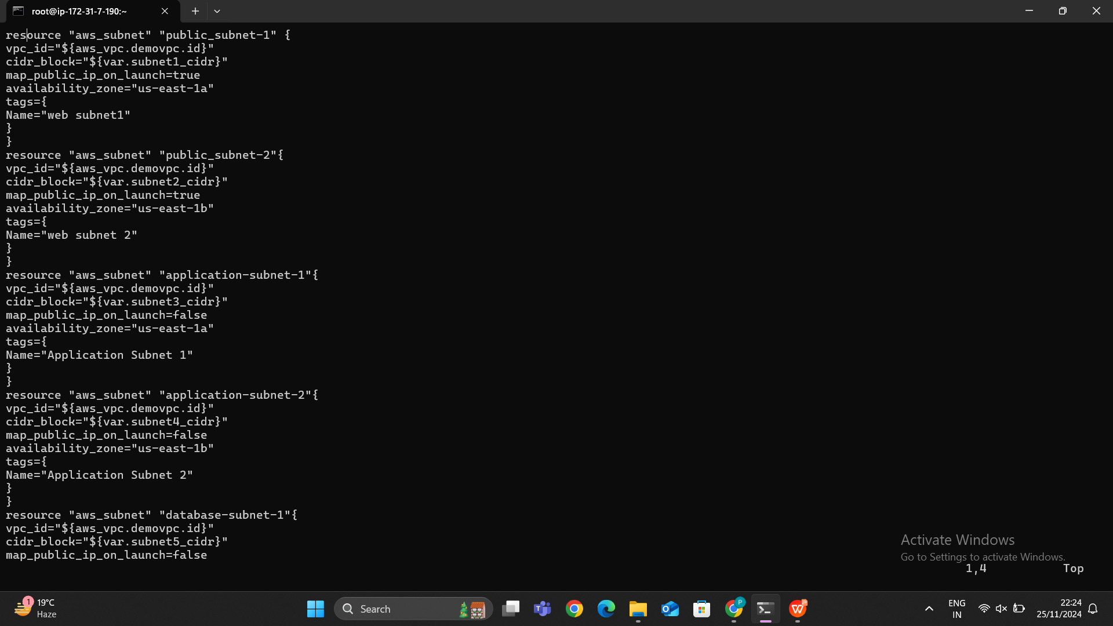

Each subnet needs its own IP range, so you define a CIDR block (like 10.0.1.0/24). This places the subnet in a specific availability zone. This is set to true to assign public IPs to instances launched in this subnet, making it a public subnet. Adds a tag (Name = "My Subnet") for easier identification in the AWS console. After creating an subnet.tf file we need to run the terraform plan command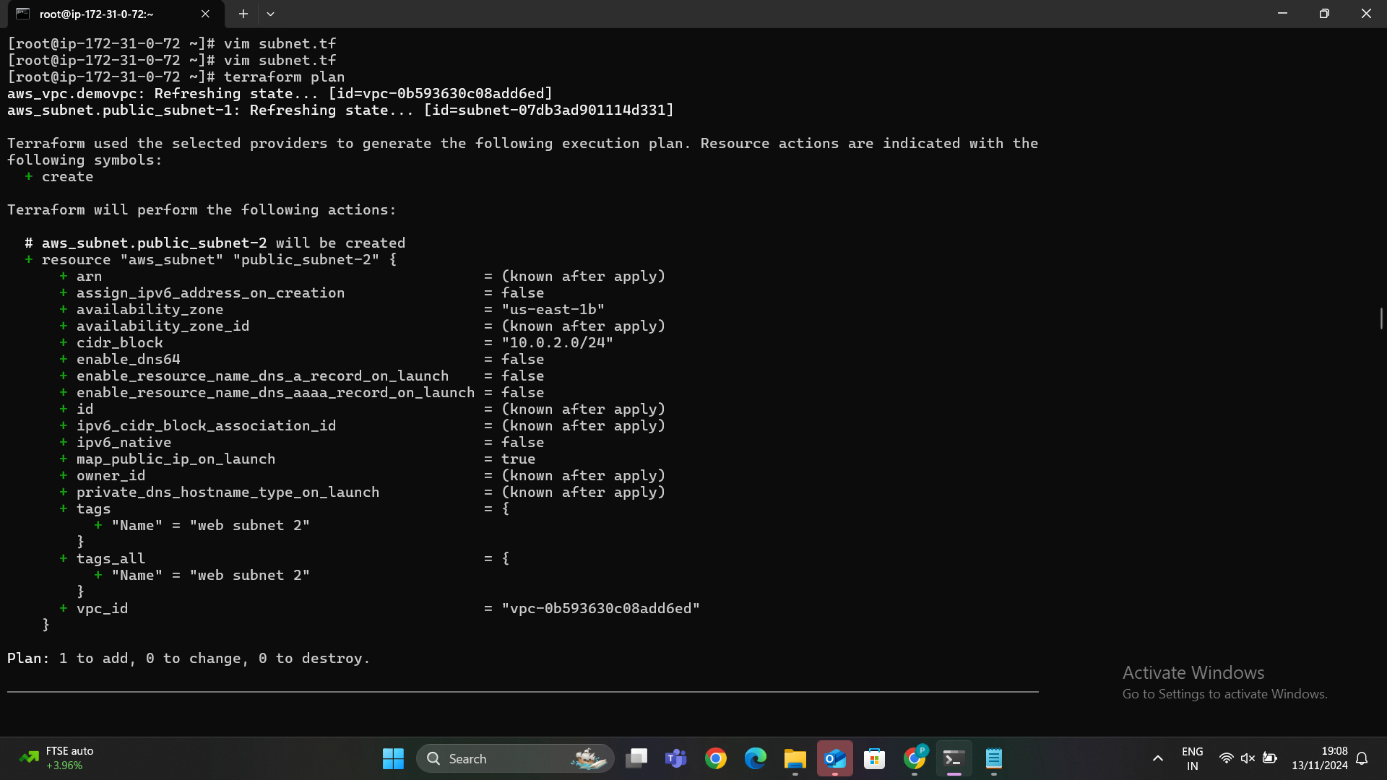.

It will check every subnet configuration is correct or not.

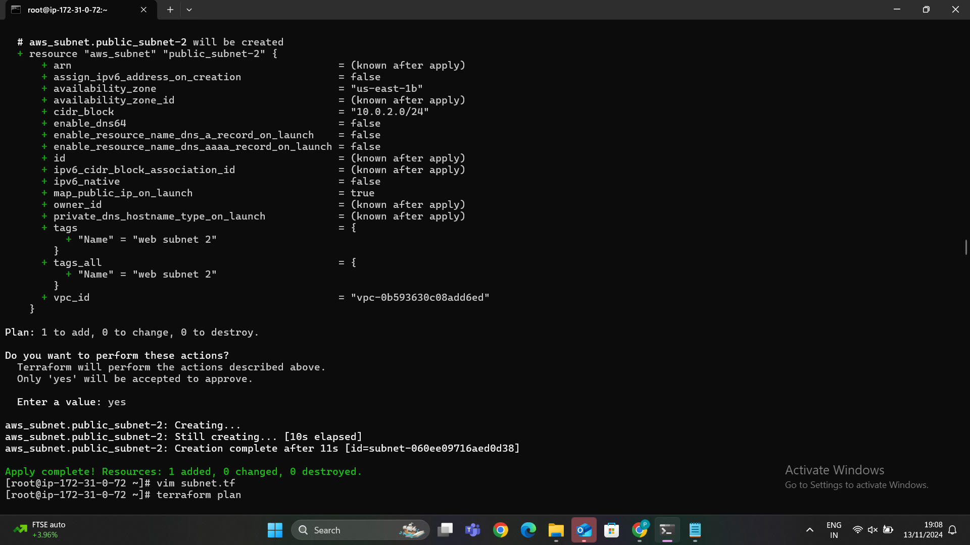

After successfully completion of terraform plan then we need to apply using terraform apply command we can see in the below image.

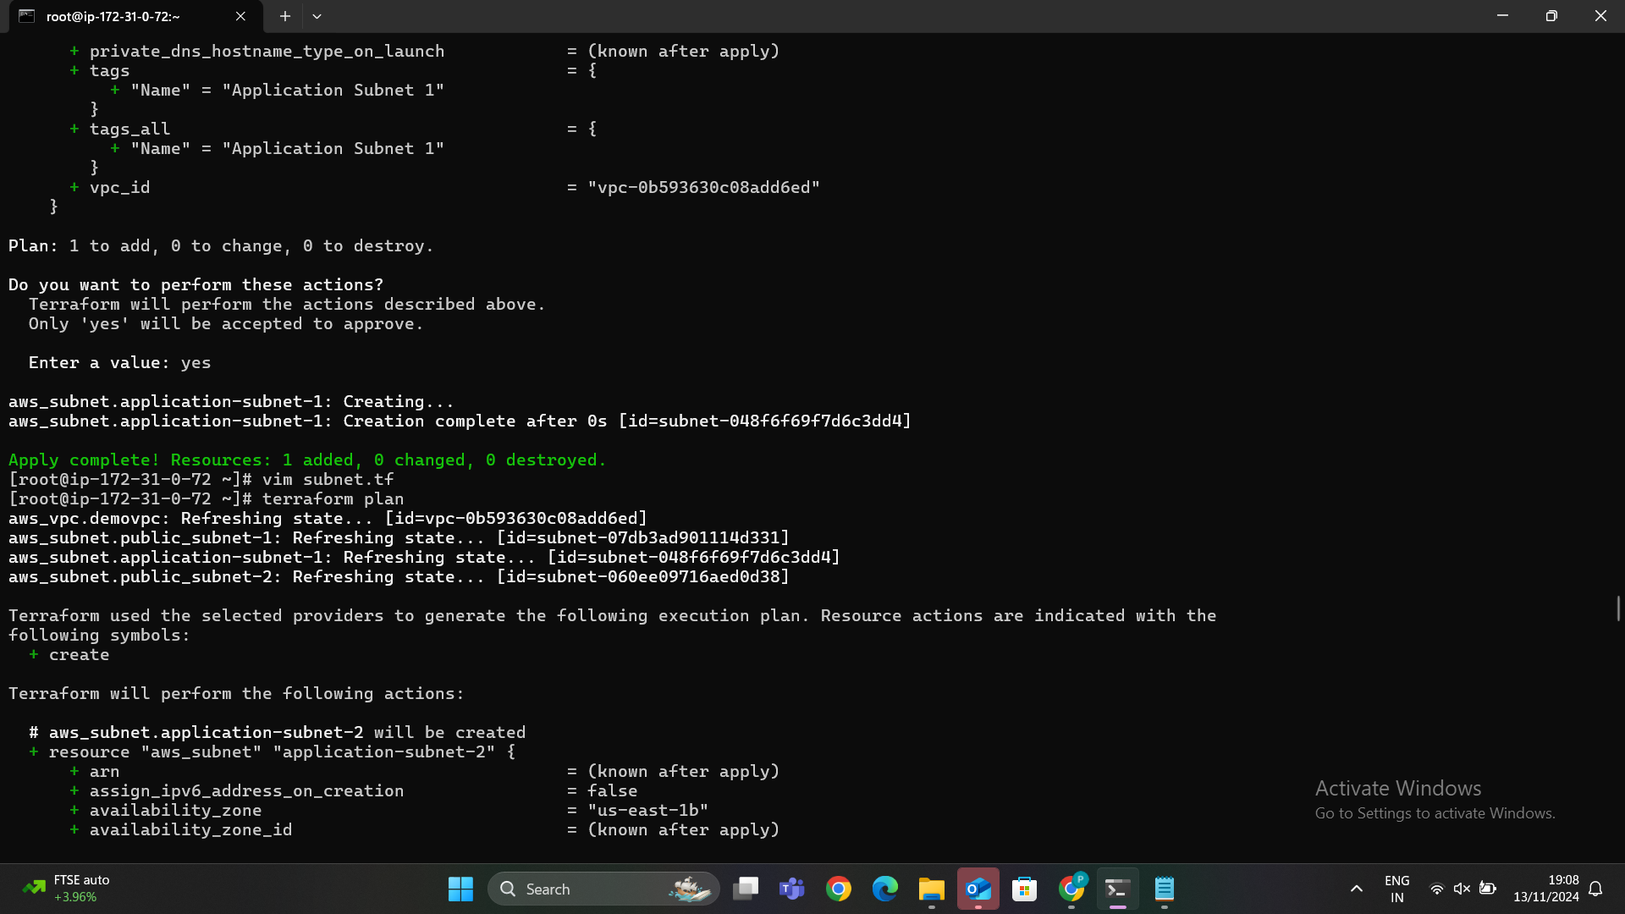

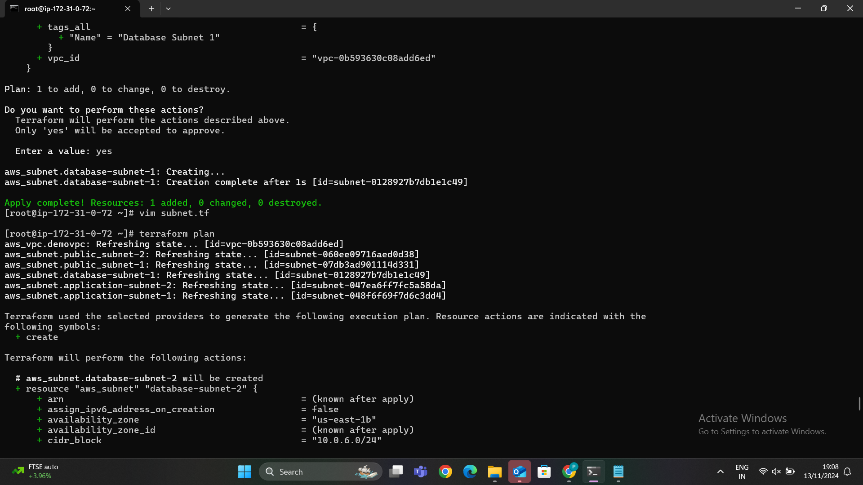

In the below image we can able to see that terraform apply was successful. Then we need to go AWS account and search for VPC in that we can able to see subnets click on that and check in the subnets.

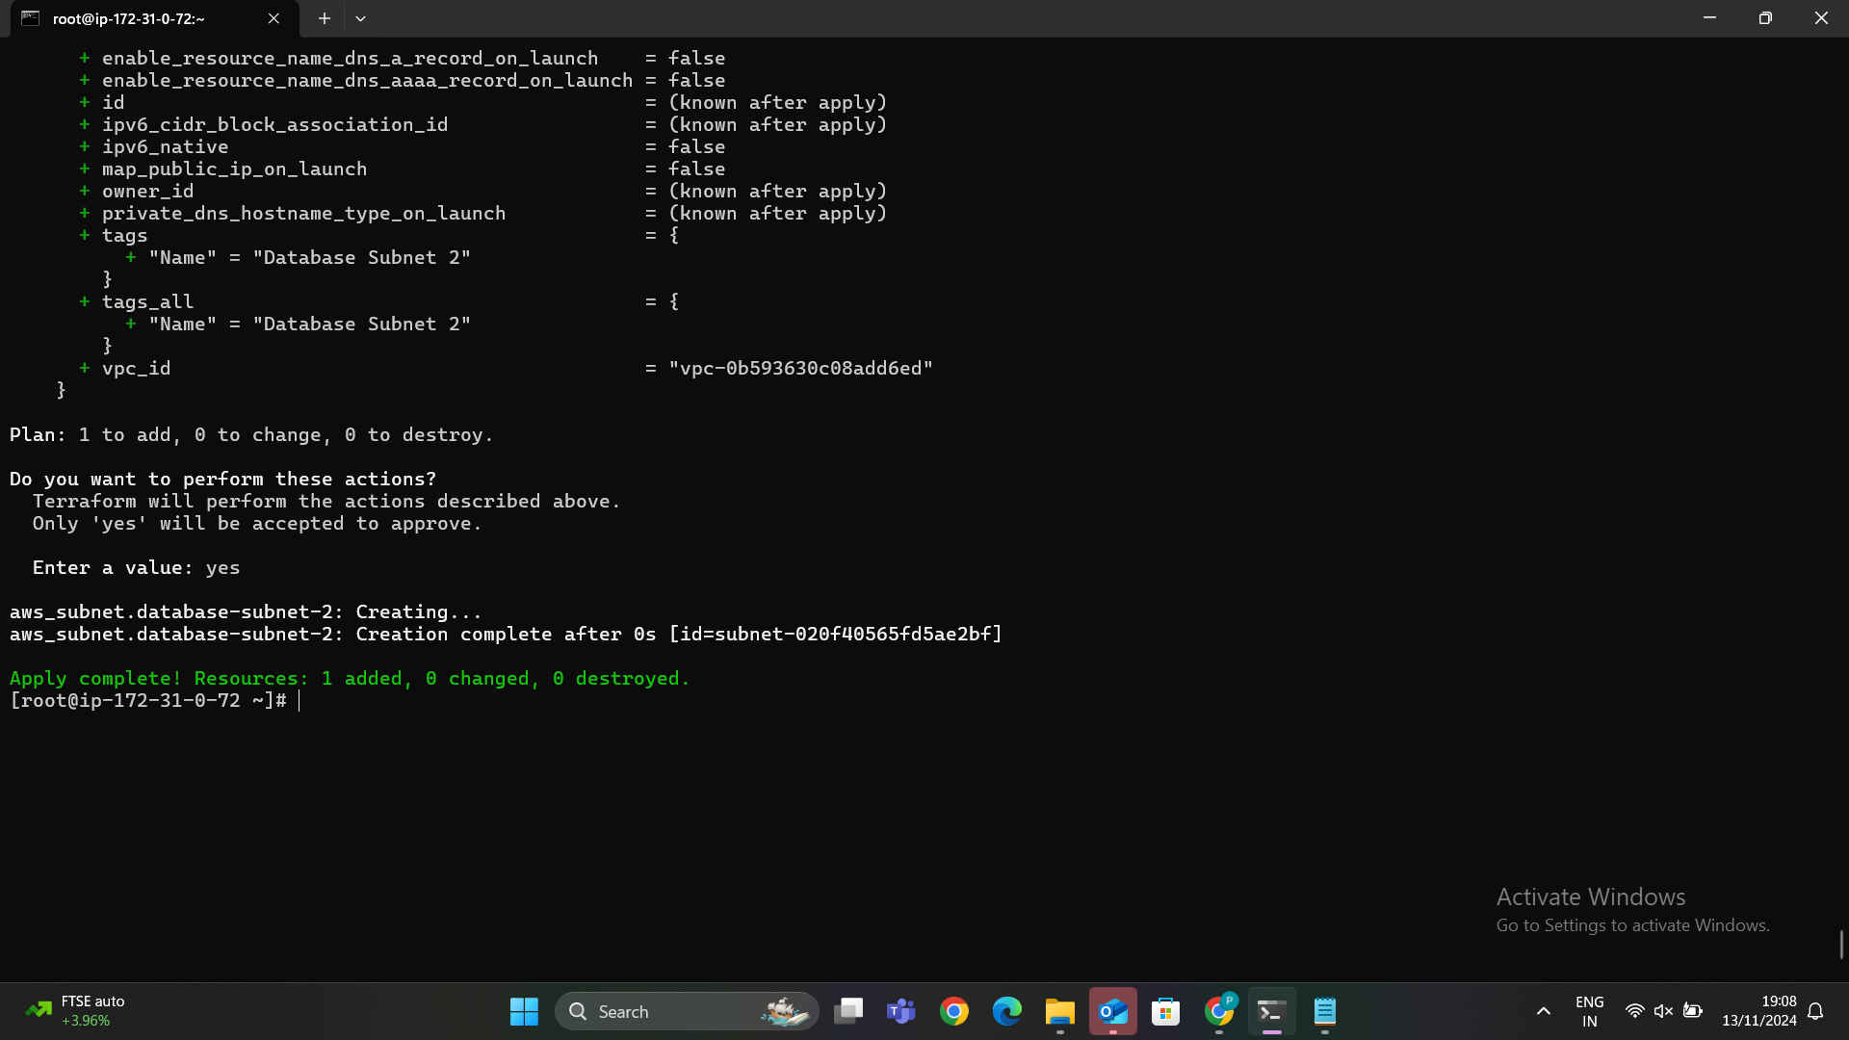

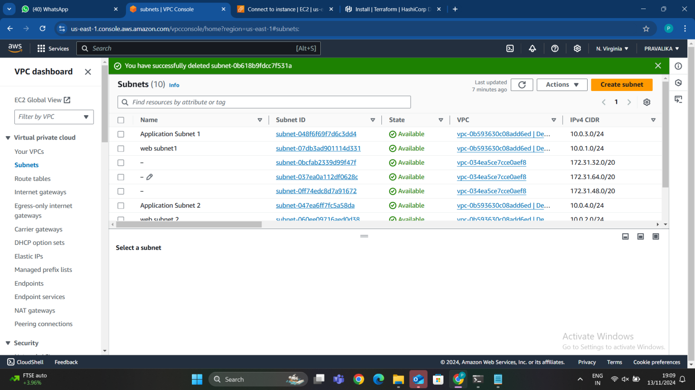

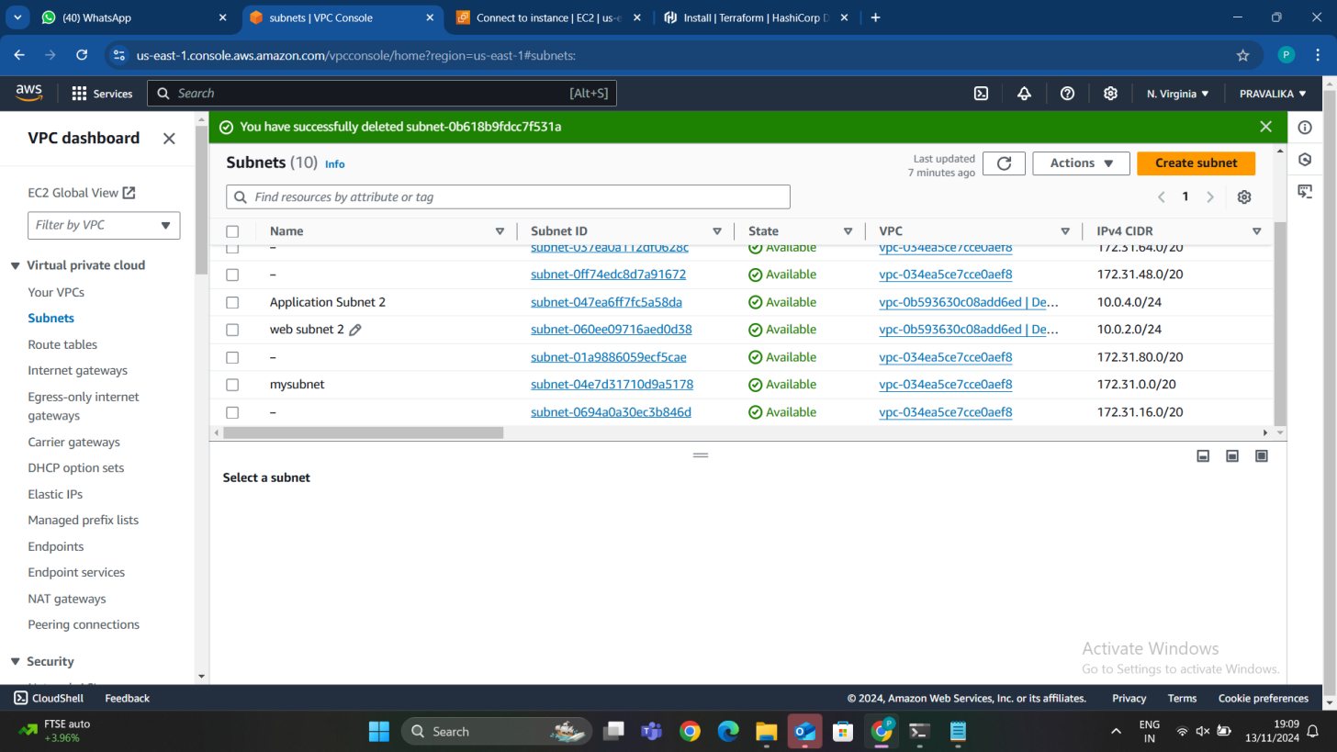

Application subnets has been created successfully as shown in below image.

## STEP 4: CREATE INTERNET GATE WAY

### Creating an Internet Gateway in Terraform

To enable internet access for resources in your AWS Virtual Private Cloud (VPC), you need to create an **Internet Gateway** using Terraform. This is typically defined in a file like igw.tf. The Internet Gateway serves as a bridge between your VPC and the internet.

### Key Components of the Internet Gateway Configuration

#### 1. **aws_internet_gateway:**

* This is the Terraform resource used to define and create the Internet Gateway in AWS.

#### 2**. vpc_id:**

* This links the Internet Gateway to a specific VPC.
* It references the ID of the VPC you've already created (e.g., aws_vpc.my_vpc.id).

#### 3. **Tags:**

* Adding a **Name** tag helps you identify and manage the Internet Gateway easily in the AWS Management Console.

In the below image we can able to see that our igw.tf file.

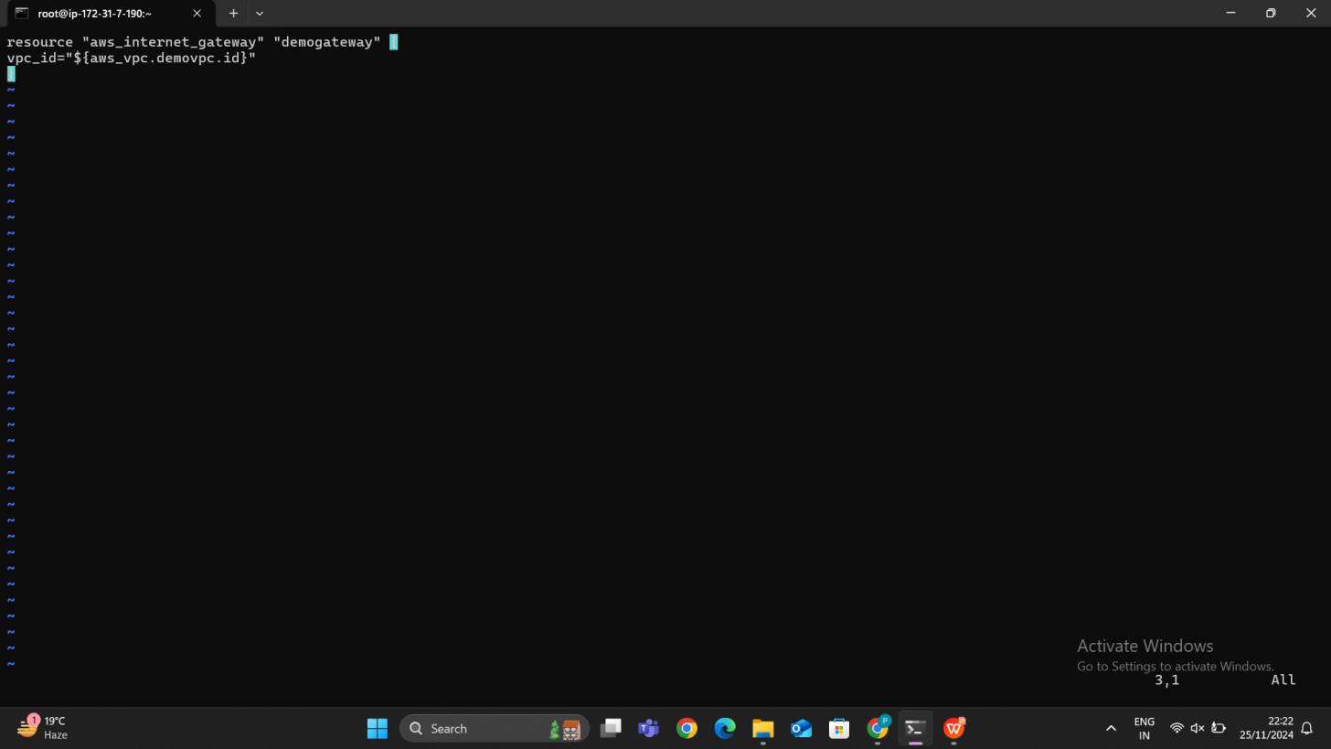

We are running an terraform plan command for any modification or preview the changes.

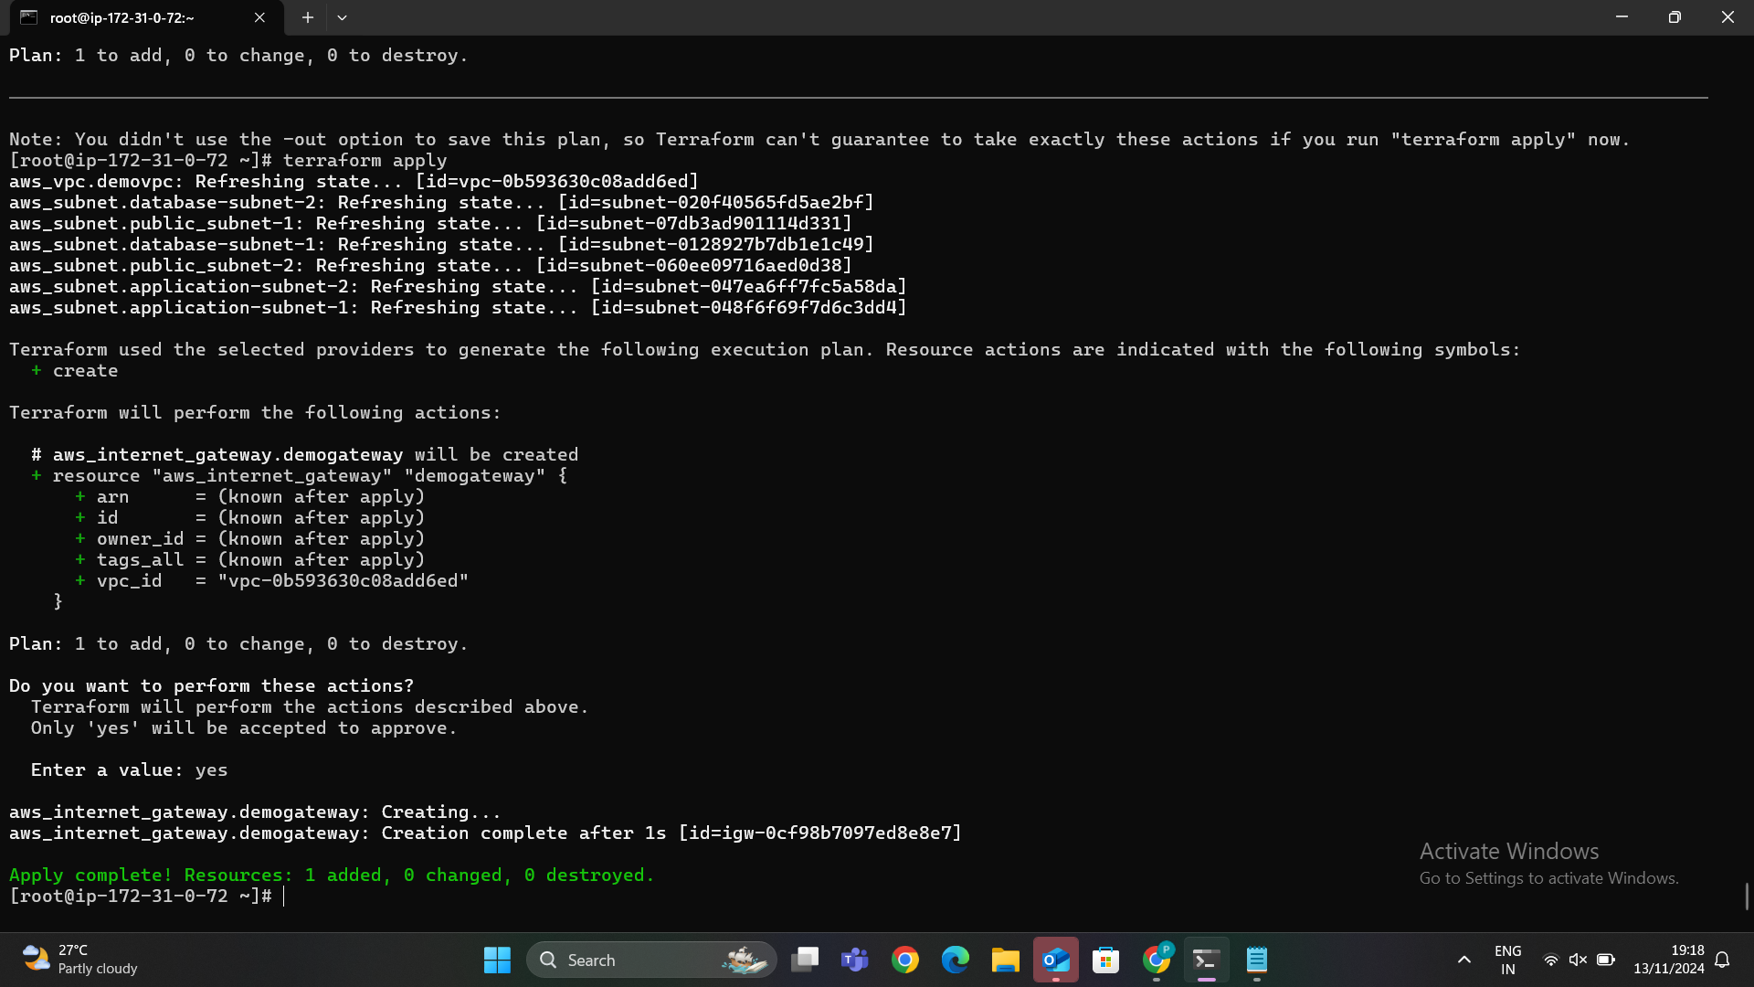

In the below image we can able to see that **terraform apply** for the applying the changes to create a internet gateway.

In the below image we can able to see that our Internet gateway has been created successfully and attached to VPC.

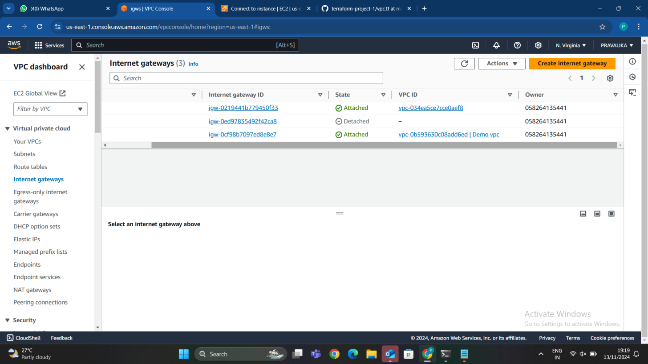

## STEP 5: CREATING THE ROUTING TABLE

## A **route table** in Amazon Web Services (AWS) defines the routes for network traffic within your **Virtual Private Cloud (VPC)**. Each **subnet** in a VPC must be associated with a route table that controls how traffic is directed to other subnets or the internet.

### ****Key Concepts****

**Route**:

* 1. A **route** specifies how traffic destined for a particular IP address or range of IP addresses (CIDR block) is directed.
  2. For example, a route might forward traffic destined for 0.0.0.0/0 (the entire internet) to an **Internet Gateway (IGW)** for internet-bound traffic.

**Main Route Table**:

* 1. Every VPC comes with a **default main route table**, which is automatically associated with all subnets in the VPC unless you create and assign a custom route table.
  2. You can modify the main route table or create new route tables to suit specific needs (e.g., one route table for private subnets, another for public subnets).

**Custom Route Tables**:

* 1. You can create **custom route tables** and associate them with specific subnets. This allows fine-grained control over how traffic is routed in different parts of your VPC.

**Routes** in Route Tables:

* 1. **Destination CIDR block**: The IP address range for the route.
  2. **Target**: The destination where the traffic should be forwarded, such as an Internet Gateway (IGW), Virtual Private Gateway (VGW), NAT Gateway, or another subnet.

**Propagation**:

* 1. In some cases, route tables can have **propagation** enabled, meaning they can dynamically update routes based on changes in network configuration (e.g., VPN routes, VPC peering).

### ****Route Table Types****

1. **Public Route Table**:
   1. A public route table is associated with **public subnets**. It typically includes a route for internet-bound traffic (0.0.0.0/0) that points to an **Internet Gateway (IGW)**.
2. **Private Route Table**:
   1. A private route table is used for **private subnets**. It does not directly allow traffic to the internet, but it can route traffic through a **NAT Gateway** (for outbound traffic) or a **VPN Gateway** (for private connections).

### ****Route Table Components****

**Routes**:

* 1. A route in a route table consists of:
     1. **Destination**: The target CIDR block (IP address range).
     2. **Target**: The resource where the traffic is directed (e.g., an IGW, NAT Gateway, VGW).

**Route Table Associations**:

* 1. Each subnet must be associated with a route table, which determines how traffic leaving the subnet is routed.
  2. The association is what links the subnet to its route table, ensuring that the correct route is used based on the destination.

## A Route Table is like a map that guides the flow of network traffic within your VPC (Virtual Private Cloud) in AWS. It decides where data should go when it leaves a resource, such as an EC2 instance. For example, it can direct traffic to the internet, other subnets, or a VPN connection. I have created an route_table_public.tf file to create a route table.

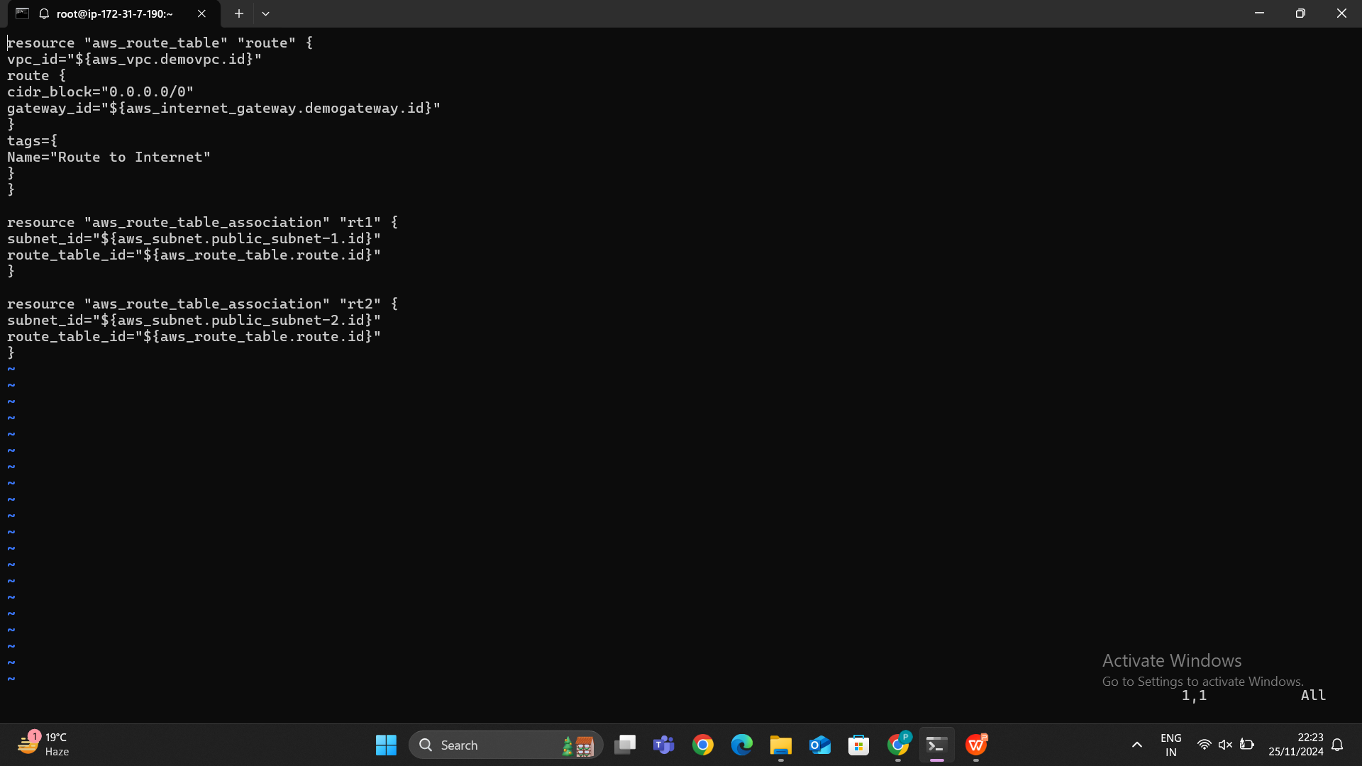

0.0.0.0/0 → Internet Gateway (for internet access).

Subnet CIDRs → Local traffic within the VPC.

Private IP ranges → NAT Gateway for outbound internet access without exposing resources.

### Why Route Tables are Important:

**Control Traffic Flow:**

* 1. Route tables ensure that data flows to the **correct destination**. For example, traffic from a private subnet can go to the internet via a NAT Gateway, while traffic from a public subnet goes through an Internet Gateway.

**Enables Internet Access:**

* 1. By specifying routes to the **Internet Gateway**, route tables make it possible for your VPC to connect to the internet or other external networks.

**Network Segmentation:**

* 1. Route tables help you **isolate** different parts of your network. You can control which subnets are public or private and define how traffic flows between them.

In the below image I have run the terraform plan command because I have review the changes and if any error occurs I can able to find it before applying.

After completion of terraform plan there is no error or any mistake so it is ready for applying so I used terraform apply command to make changes and to create a route table.

In the below image we can able to see that our apply is successful then we need to go to AWS VPC and then click on route table then we can able to see that our route table as been created successfully.

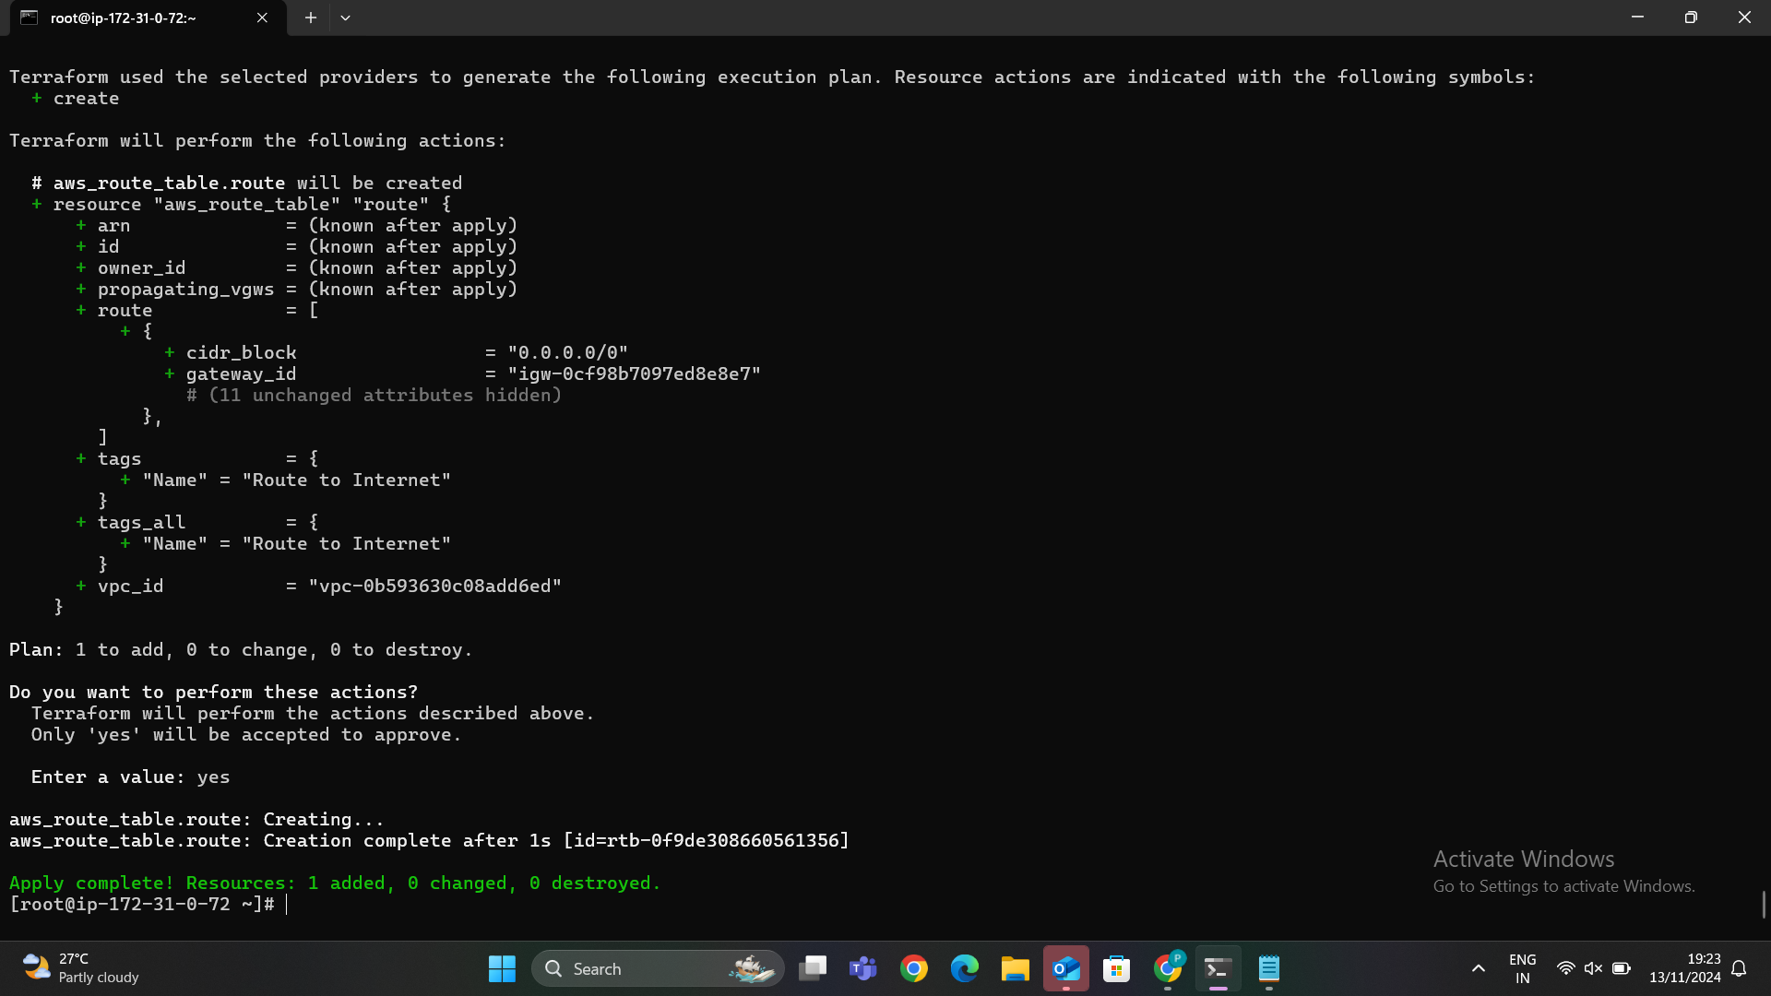

In the below image we can able to see that our route table as been created successfully.

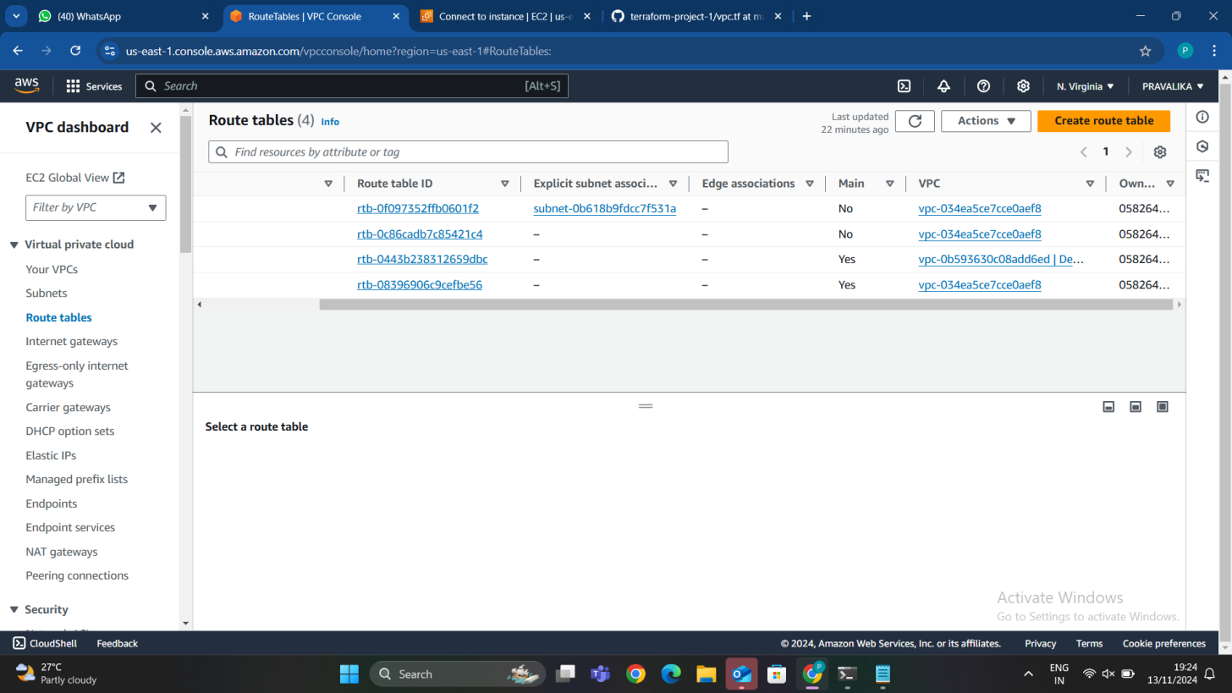

In the below image we can able to see that the toute association.

After creating VPC, Subnets, Internet gateway, Route table then go to VPC and click on VPC in that we can able to see Route map click on that and we can able to see a map for the creation of our VPC and subnet attachment to which route table and connected to which network connection.

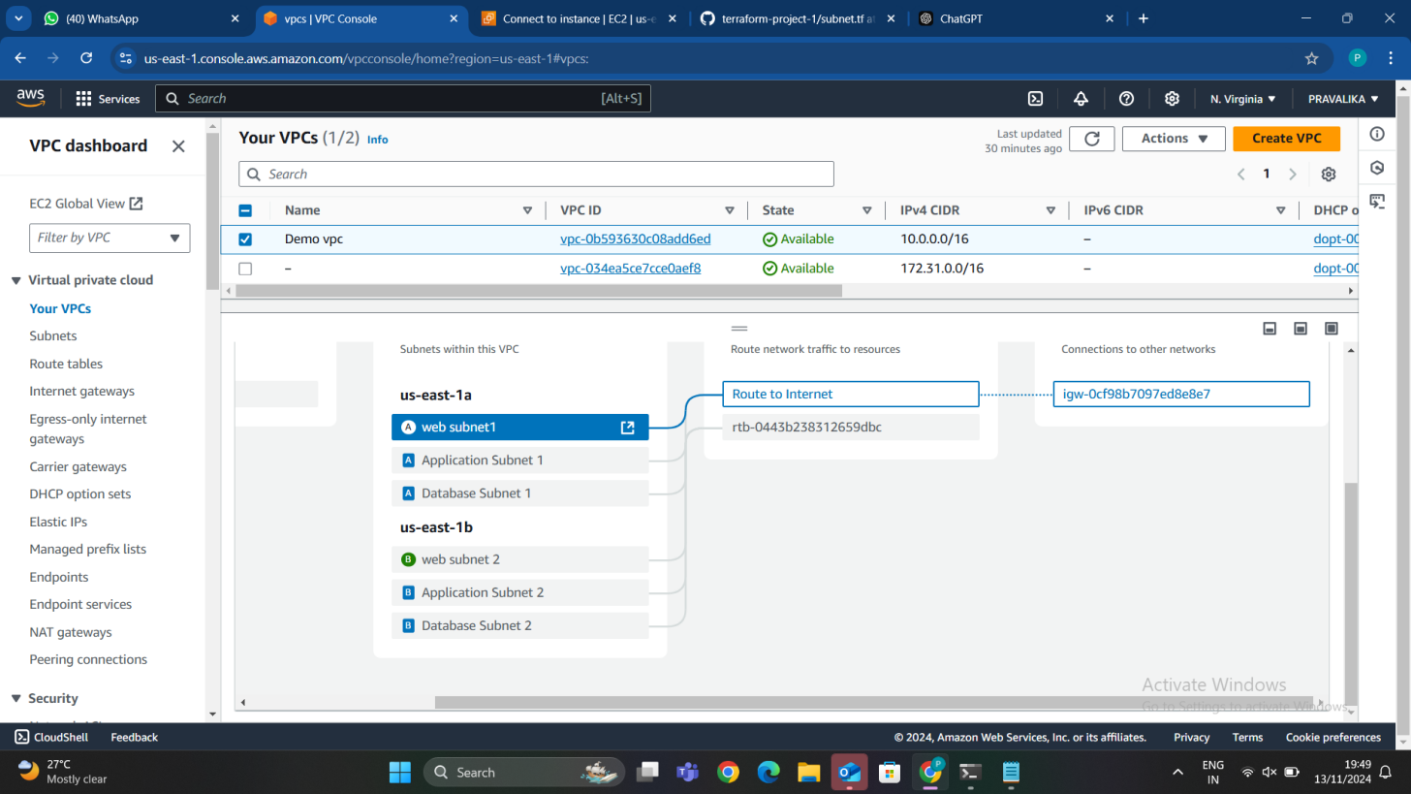

## STEP 6: CREATING A SECURITY GROUP

A **Security Group** in AWS serves as a virtual firewall that helps protect your resources, like EC2 instances, from unwanted network traffic. It defines rules that control which inbound and outbound network traffic is allowed to reach or leave your resources. In simple terms, a Security Group acts as a set of security rules that determines who can communicate with your EC2 instances and what kind of communication is allowed.

Before launching an EC2 instance, you can define the security rules by creating a **web_sg.tf** file. This file specifies the rules for your Security Group, such as allowing HTTP and HTTPS traffic to your web servers.

### Example Workflow:

**Create the Security Group (**web_sg.tf**):**

* 1. In this step, you define the rules that allow specific traffic (e.g., HTTP, HTTPS) to reach your EC2 instance, ensuring your web server is accessible

**Launch EC2 Instance:**

1.After defining your Security Group, you can associate it with an EC2 instance during creation. The EC2 instance will follow the security rules defined in the web_sg.tf file.

In summary, the **Security Group** controls **who can access** your EC2 instance and **how** they can communicate with it, ensuring your infrastructure remains secure.

I have used terraform apply command to make changes and create an security group for an ec2 instance.

In the below image we can able to see that the terraform apply as been successfully applied. So now we can able to go and check in the security group we can able to see our new security group called **Web SG.**

A **Security Group for the Frontend** refers to a set of rules that control the inbound and outbound network traffic to resources in the **frontend** layer of your infrastructure, such as web servers or application servers that are publicly accessible.

In a typical web application, the **frontend** is the part that users interact with, like a website or web application hosted on an EC2 instance. To secure the frontend, you need a Security Group that specifies which network traffic is allowed and which is blocked.

### Key Points:

**Inbound Rules (Ingress):**

* 1. Allow **HTTP (port 80)** and **HTTPS (port 443)** traffic from anywhere (0.0.0.0/0). This enables users to access your frontend resources over the web.

**Outbound Rules (Egress):**

* 1. Allow all outbound traffic. This might be necessary if your frontend needs to communicate with other services (e.g., APIs, external databases).

**Security Group Name and Description:**

* 1. The security group is named frontend-sg, and a description is provided for clarity.

### Purpose:

* The **Frontend Security Group** is designed to allow web traffic (HTTP and HTTPS) to your public-facing EC2 instances (web servers). By controlling what traffic is allowed, it helps to protect your frontend layer from unauthorized access while ensuring legitimate users can interact with the web application.

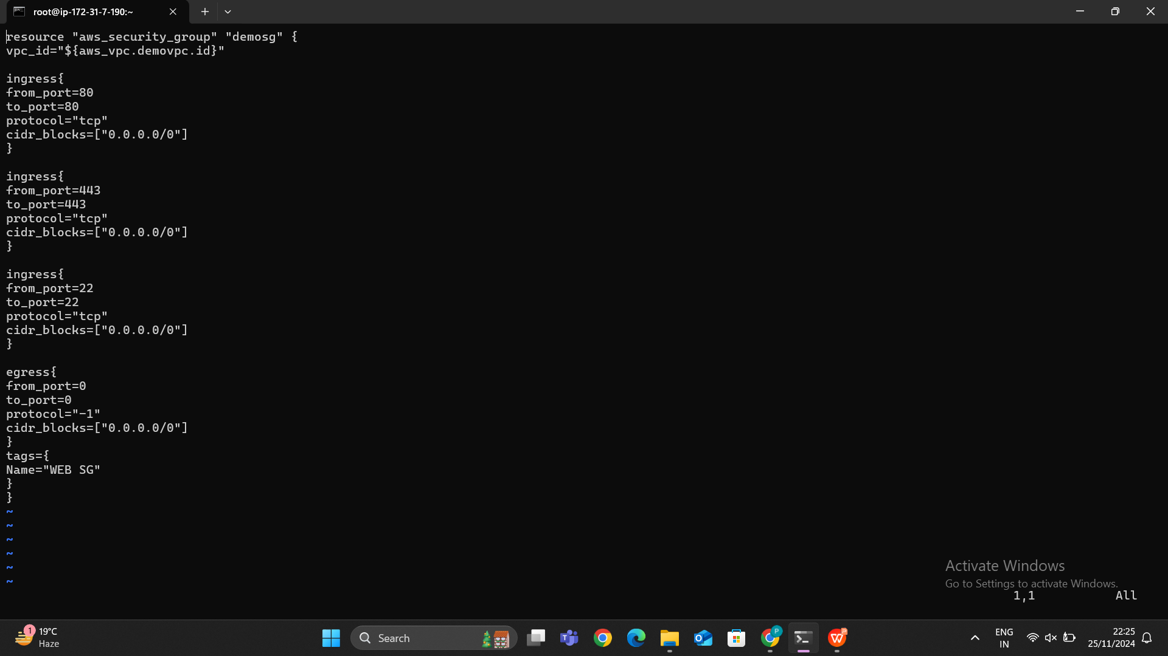

In the below image we can able to see that our new security group has been created successfully.

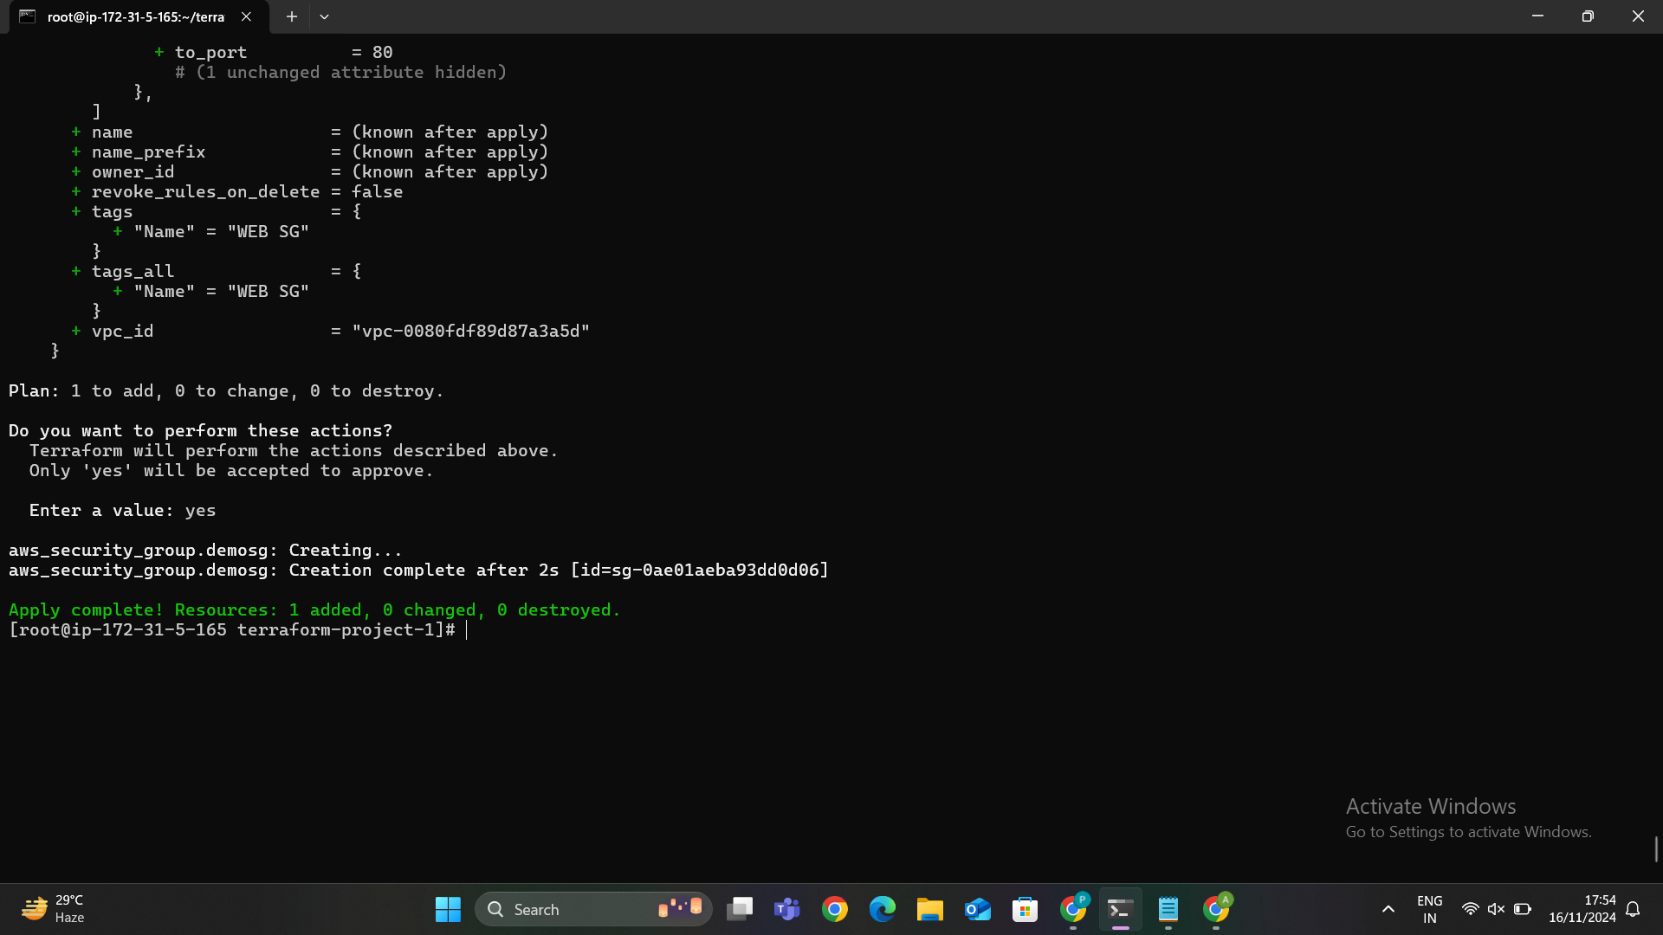

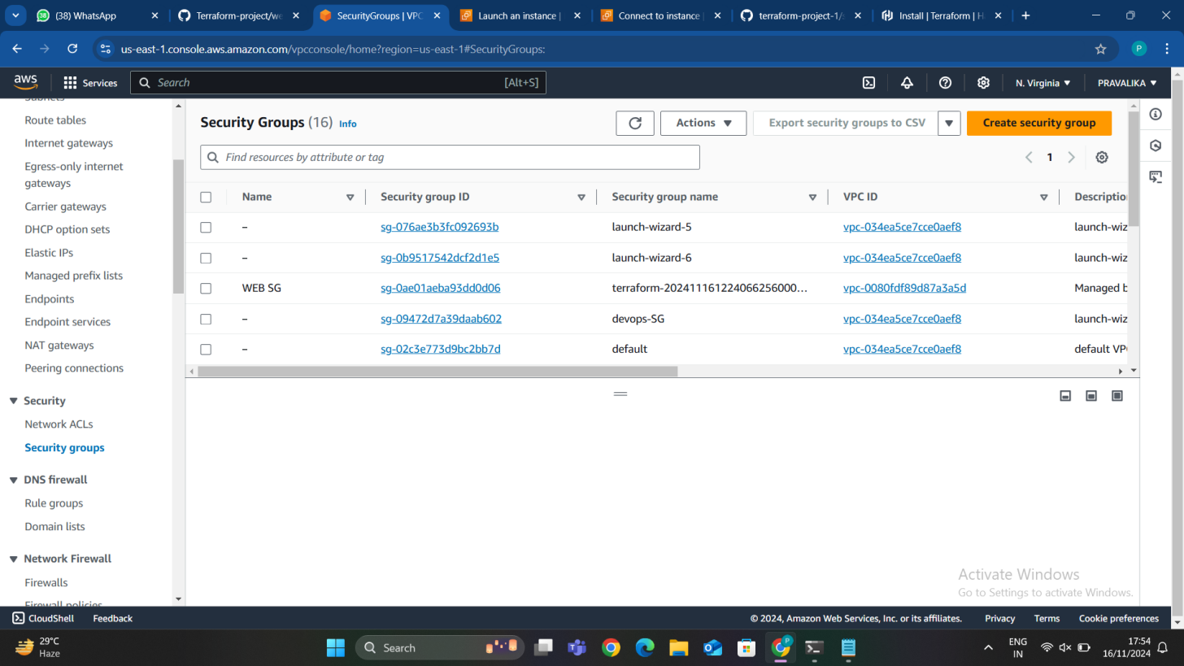

## STEP 7: CREATING AN USER DATA

## We are creating an data.sh because if we want to create an instance. The data.sh file is a shell script that you can use to automate the setup of your EC2 instance when it starts. By including this file in the User Data section, you ensure that the necessary software and configurations are automatically applied without having to manually log into the instance after it's launched.

## Screenshot 2024-11-25 222121

## I have used terraform plan and apply for the data.sh.

## Screenshot 2024-11-28 215357

## Screenshot 2024-11-28 215501

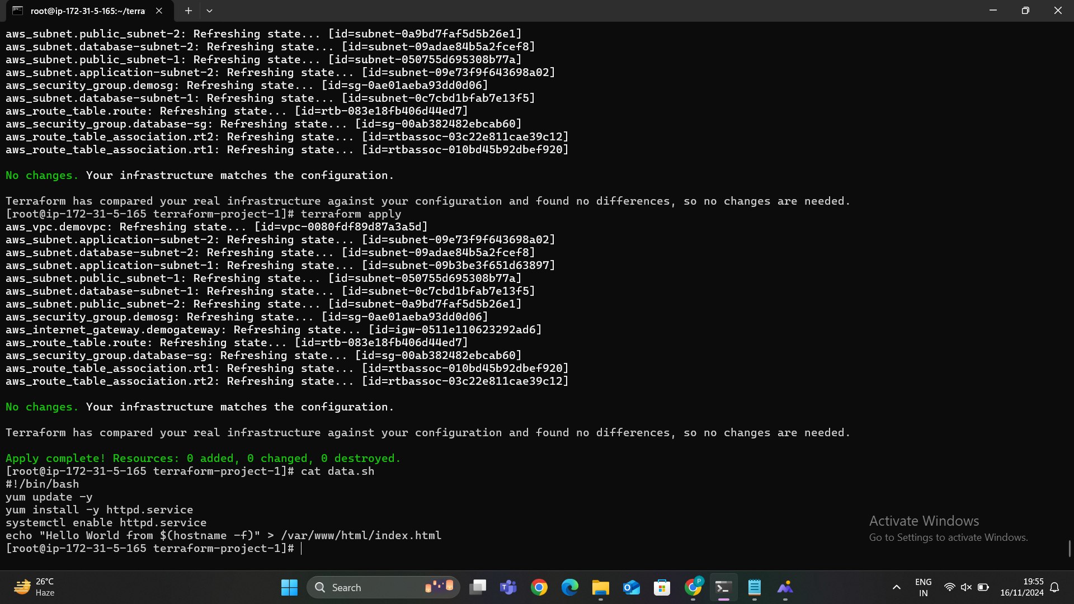

In the below image we can able to see that the output for the user data.

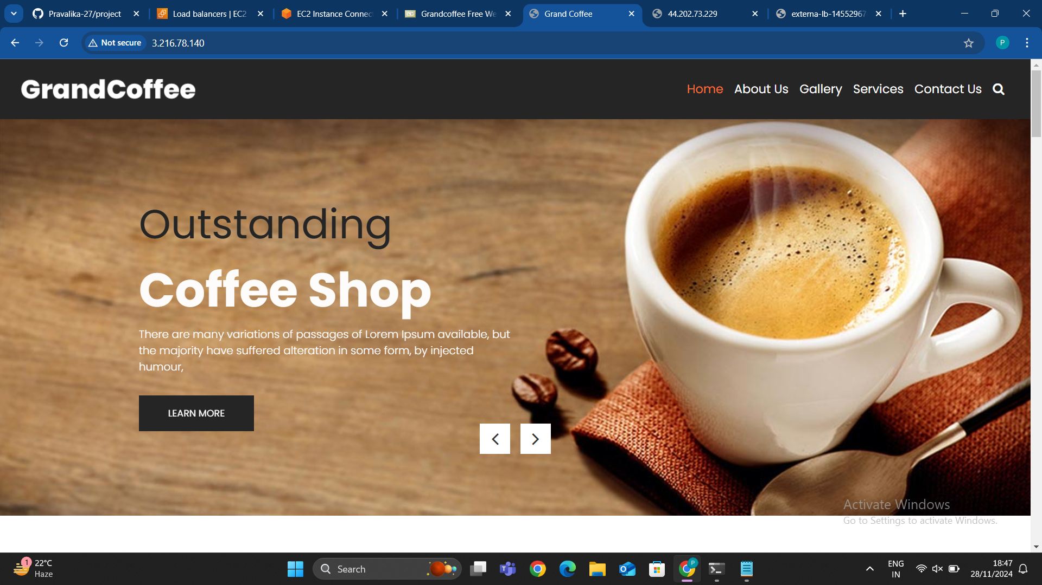

## STEP 8: CREATING AN EC2 INSTANCES

## To create an EC2 instance in AWS using Terraform, we need to define the configuration in a file ec2.tf file. This file contains all the details about your EC2 instance, such as the Amazon Machine Image (AMI), instance type, security groups, and other settings. I have created 2 instances.

## Screenshot 2024-11-25 222222

After creating an ec2.tf file then i have run a terraform plan command and terraform apply command to check and create an ec2 instances based on our configuration.

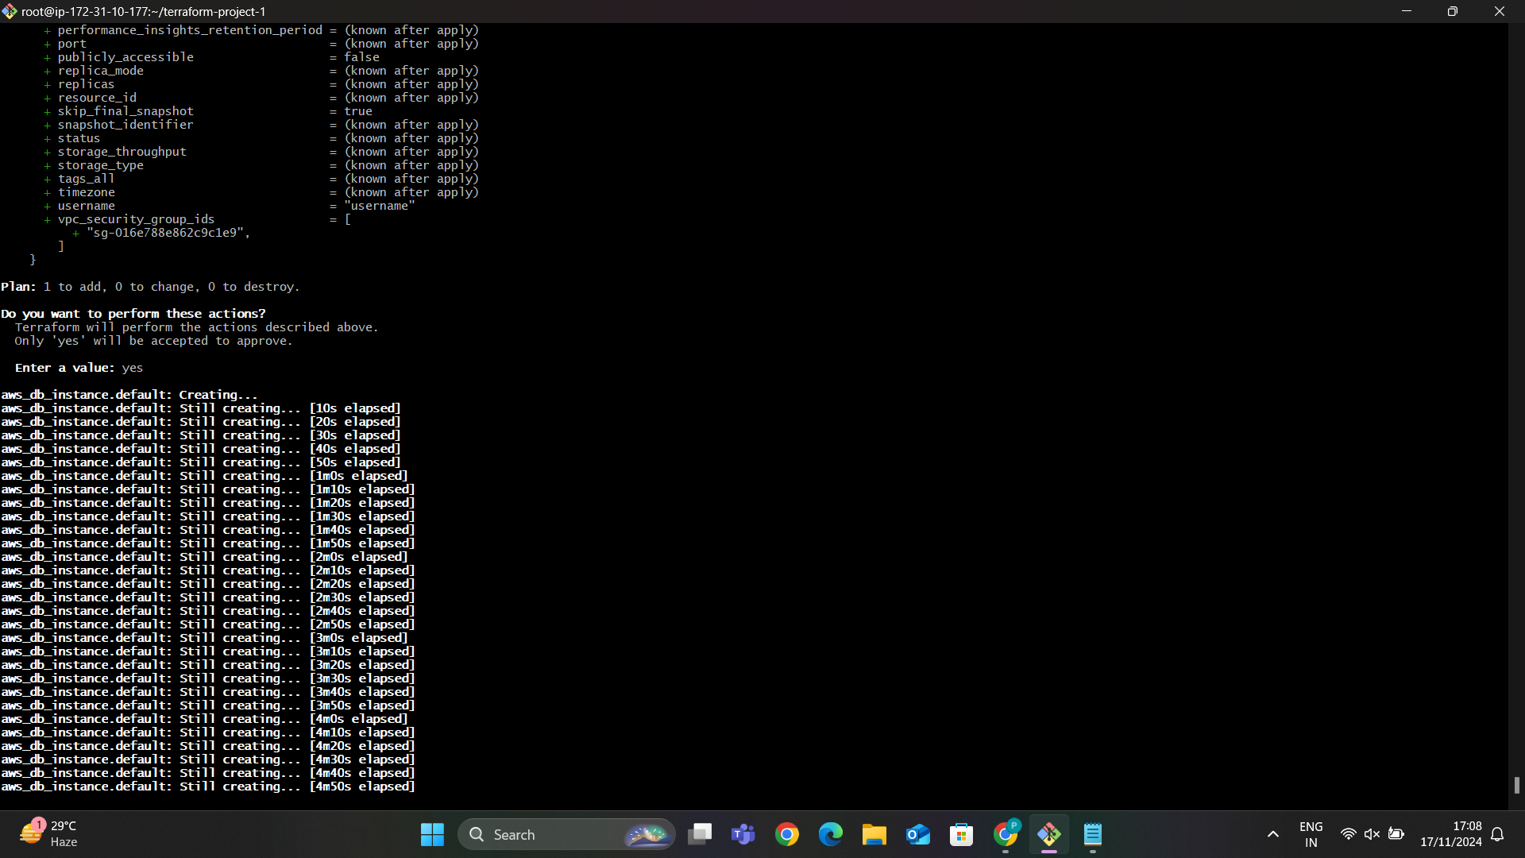

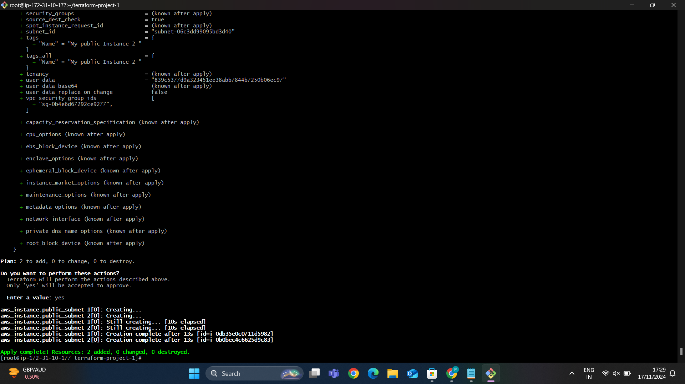

In the below image we can able to see that our newly created 2 instances has been created successfully.the below image is the first instance details.

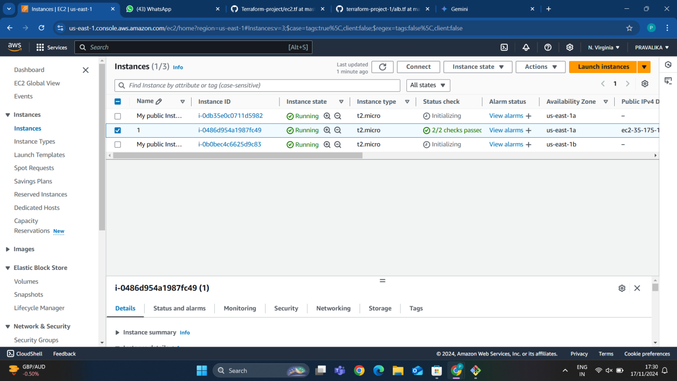

After creating an instances if we want to check that user data is working or not we need to copy the public IP of the instance and paster it in browser it throughs an error because it is https:// we need to remove the “s” http:// and again reload we can able to see the user data content.



We need to do the same process for the second instance then we can able to see like a below image.

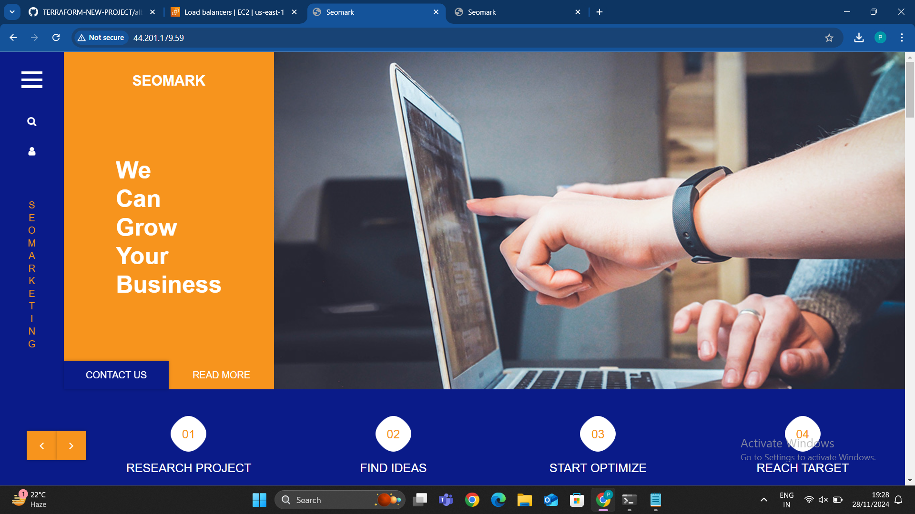

## STEP 9: CREATING A FILE FOR SECURITY GROUP FOR THE DATABASE TIER

## The Security Group for the Database Tier is like a gatekeeper. It allows only specific resources (like your Application Tier) to access the database. We set rules to allow only trusted traffic (e.g., from specific IP addresses or subnets) and block all others. This ensures your database is protected and only accessible by the parts of your system that need it. So because of that I have created an database_sg.tf file.

A **Security Group for the Database** is used to define the rules that control access to database resources, such as **RDS** or **EC2 instances** running databases. This security group ensures that only authorized resources (e.g., application servers) can communicate with your database and that the database is protected from unauthorized access.

For a database security group, you typically restrict access to only the necessary resources, such as application servers or specific IP addresses. This is especially important to protect sensitive data stored in the database.

### Key Points:

**Inbound Rules (Ingress):**

* 1. **Allow MySQL (port 3306)** or **PostgreSQL (port 5432)** traffic only from the IP range or CIDR block of the application servers (e.g., 10.0.0.0/16 for the VPC subnet). This ensures only the application servers within the VPC can connect to the database.

**Outbound Rules (Egress):**

* 1. **Allow all outbound traffic** by default (e.g., for updates or communication with external systems). You can restrict this further if needed.

**Database Ports:**

* 1. The ports specified (e.g., 3306 for MySQL or 5432 for PostgreSQL) are typical database ports. Adjust these to match the type of database you are using (e.g., Oracle, SQL Server).

**Security:**

* 1. The database security group is designed to **restrict access** to the database only to trusted sources, typically your **application servers** or **services** within the same VPC or specific IP addresses.
  2. This is important because exposing your database directly to the internet or unauthorized resources increases the risk of security breaches.

### Purpose:

The **Database Security Group** is designed to:

* Protect your database by controlling who can communicate with it.
* Ensure that only the application layer (e.g., EC2 instances running the web or app server) can interact with the database, minimizing potential security vulnerabilities.
* Limit database access to only trusted resources within your VPC or private network.

By setting up a database security group in this manner, you can tightly control access and secure your database environment from unauthorized access.

## Screenshot 2024-11-25 222148

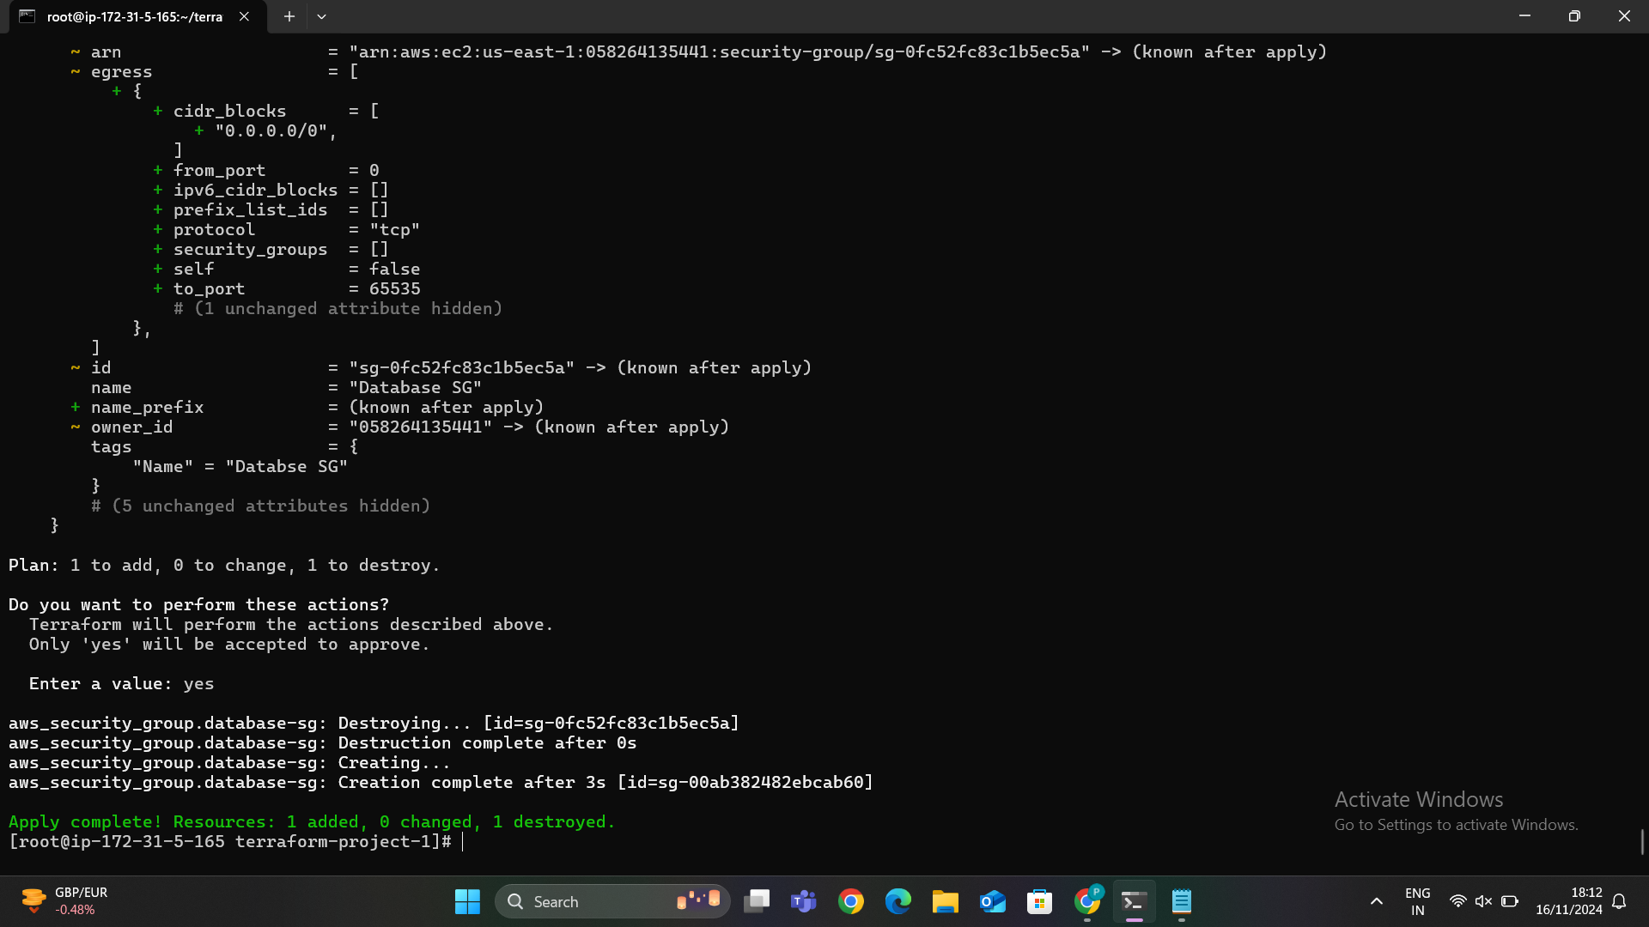

## I have create a Security Group that allows only specific sources (like the Application Tier) to access the database on specific port.

I have applied it successfully using terraform apply command.

In the below image we can able to see that our database security group has been created successfully. We can able to see the inbound rules.

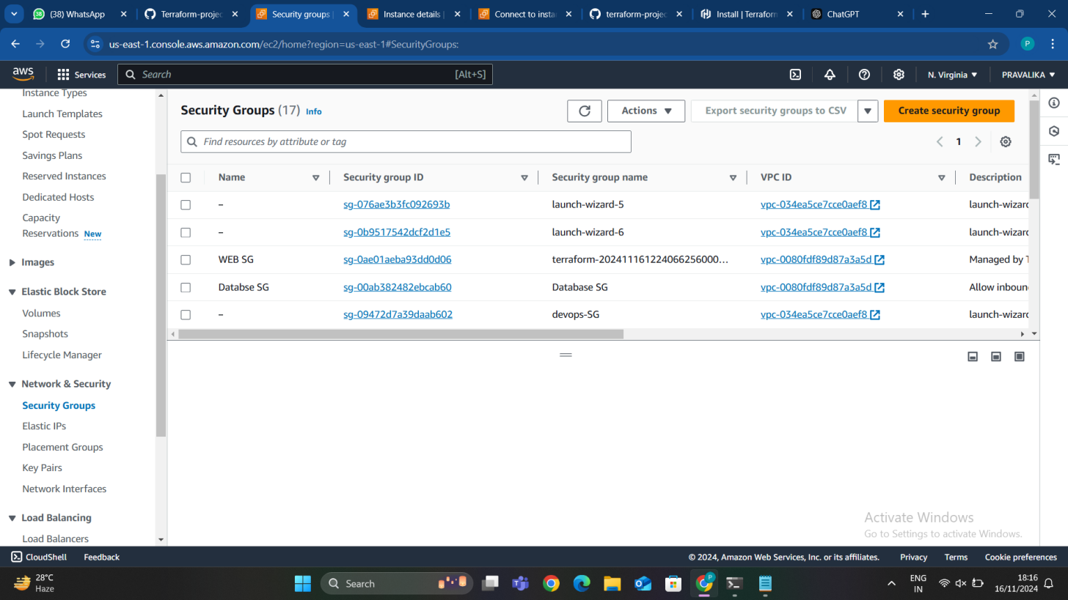

In the below image we can able to see that the outbound rules for the Database security group.

## STEP 10: CREATE A FILE FOR THE APPLICATION LOAD BALANCER

An **Application Load Balancer (ALB)** is a feature of **Amazon Elastic Load Balancer (ELB)** in AWS. It operates at the **application layer (Layer 7)** of the OSI model and is designed to manage incoming application traffic. ALB distributes requests based on content, such as URL, query string, HTTP headers, or cookies, enabling advanced routing and high availability.

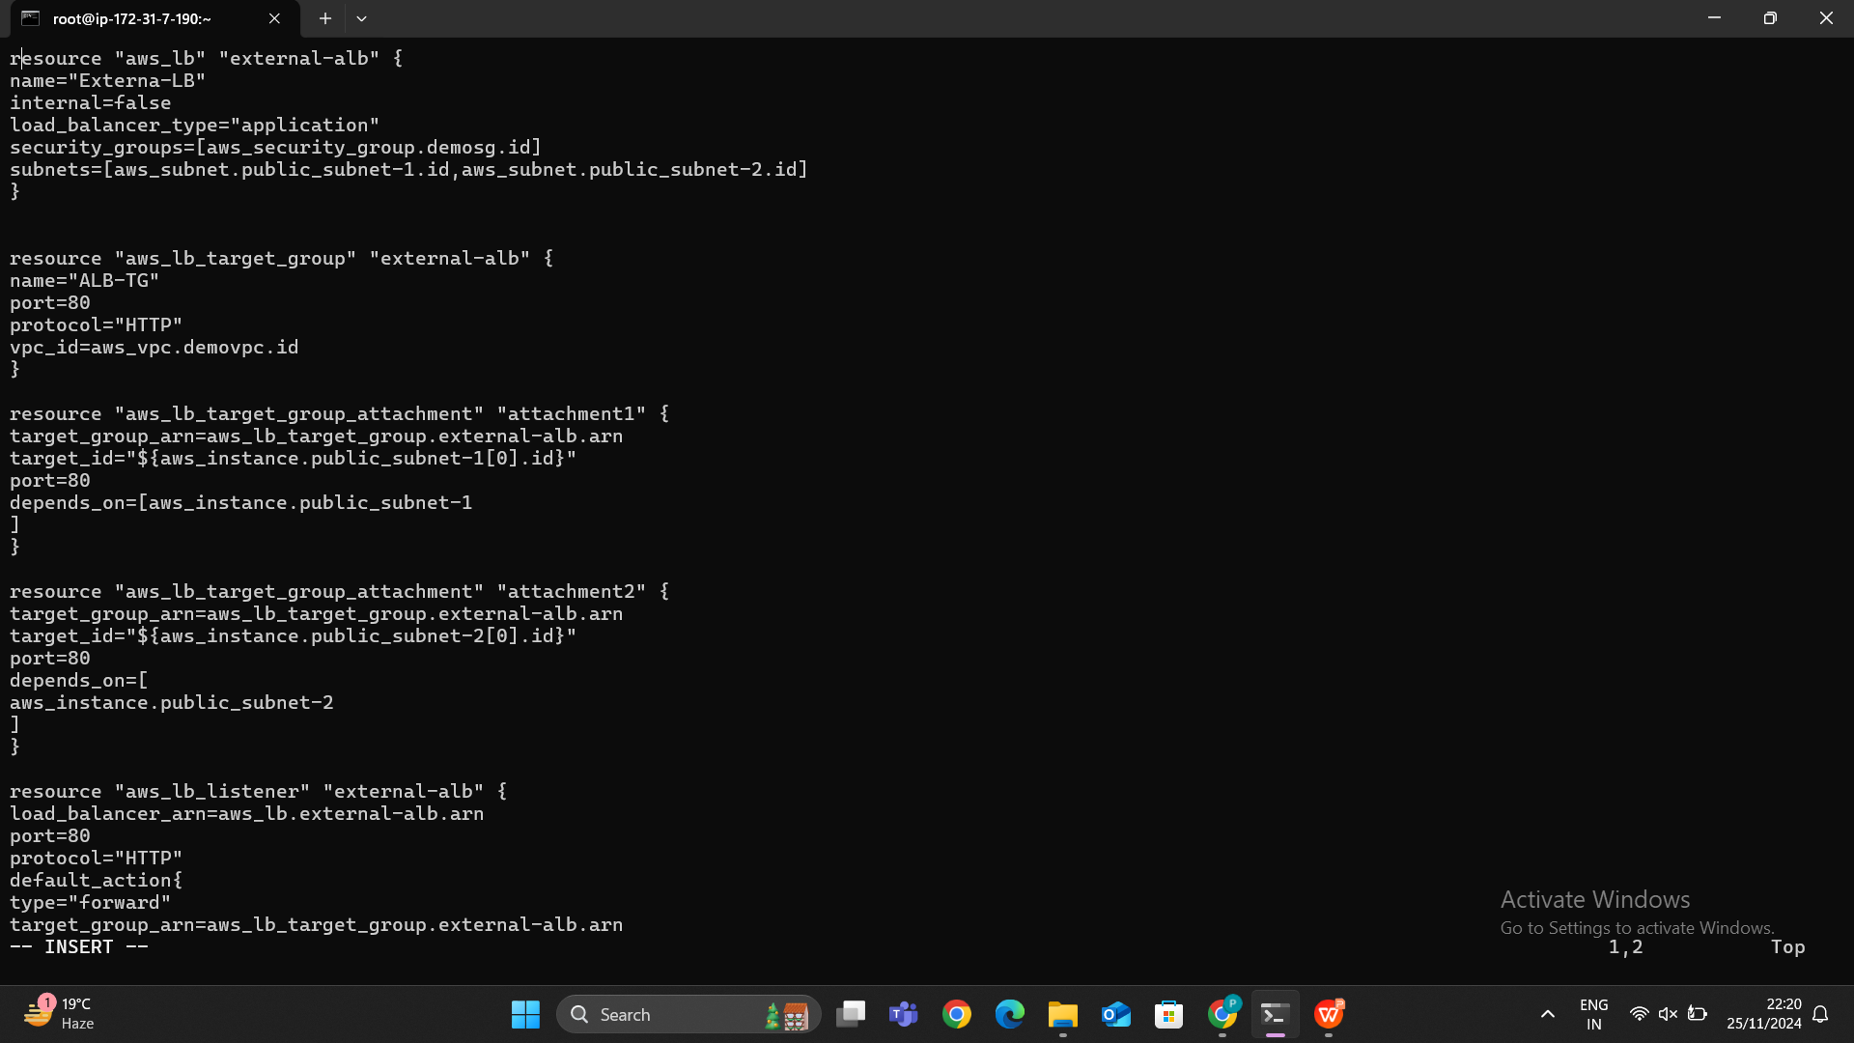

#### **Load1. Load Balancer (**aws_lb**)**

The **load balancer** serves as the entry point for your application traffic. Its configuration specifies whether it is public or private, its type, security rules, and the subnets in which it operates.

**Key Attributes:**

* name: A unique name for the Application Load Balancer (e.g., "my-app-alb").
* internal: A boolean value indicating whether the ALB is public-facing (false) or private (true).
* load_balancer_type: Specifies the type of load balancer. For ALB, use "application".
* security_groups: Associates the ALB with security groups that define inbound and outbound traffic rules.
* subnets: The subnets where the ALB will operate. Typically, public subnets are used for public-facing ALBs.

#### **2. Listener (**aws_lb_listener**)**

The **listener** defines how the ALB handles incoming requests and forwards them to the appropriate targets.

**Key Attributes:**

* port: Specifies the protocol and port the ALB listens on (e.g., HTTP on port 80 or HTTPS on port 443).
* default_action: Defines what the ALB does with incoming requests. For example:
  + forward: Routes traffic to the specified target group.
  + redirect: Redirects HTTP to HTTPS.

#### **3. Target Group (**aws_lb_target_group**)**

The **target group** is a collection of backend resources (e.g., EC2 instances, ECS containers) to which the ALB routes traffic. Health checks ensure that only healthy resources receive traffic.

**Key Attributes:**

* name: A unique name for the target group.
* protocol: Defines the protocol used for communication between the ALB and the targets (e.g., HTTP or HTTPS).
* port: The port the ALB uses to route traffic to the targets.
* health_check: Configures health checks to monitor the status of backend resources.

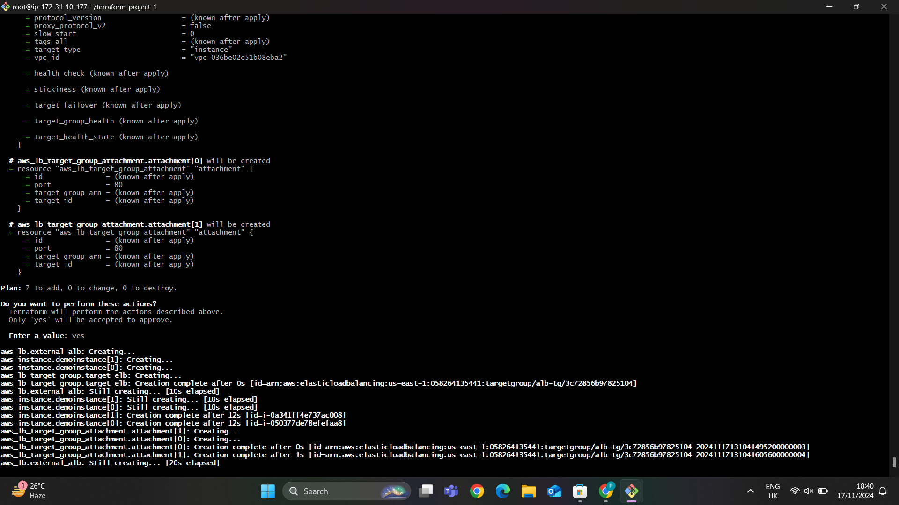

In the below image we can able to see that load balancer has been created successfully.

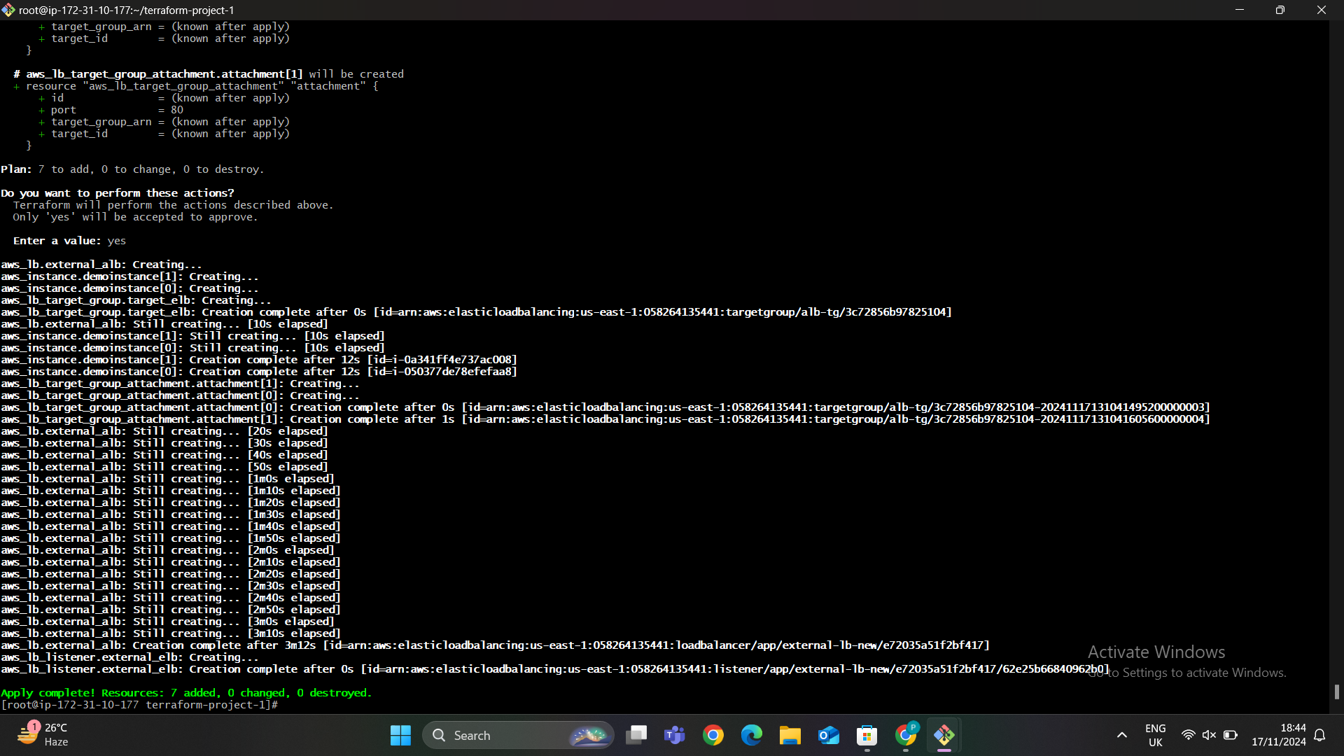

Now we can able to see the application load balancer in the below image.

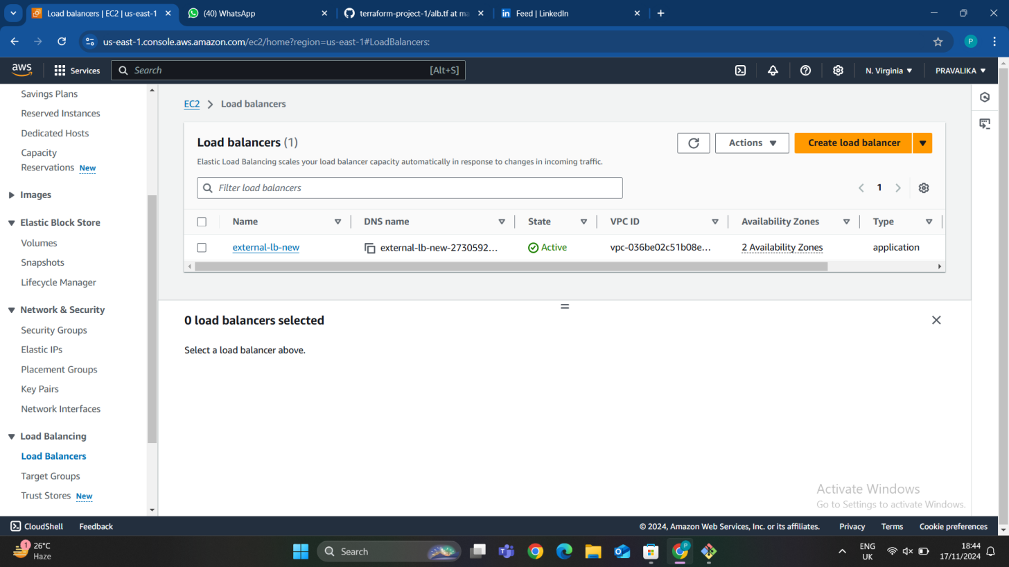

In the below image we can able to see the route map for the load balancer.

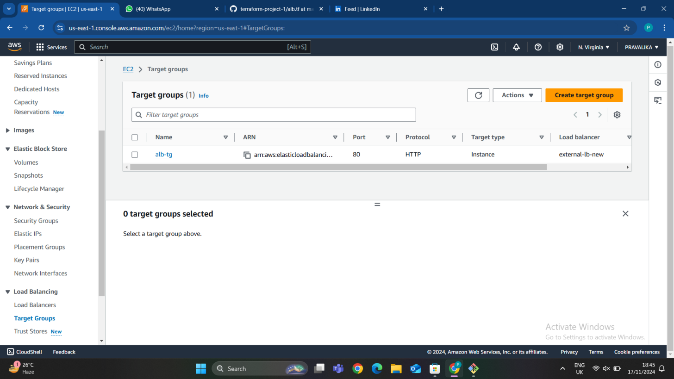

In the below image we can able to see that the target group for the load balancer and both the servers are healthy.

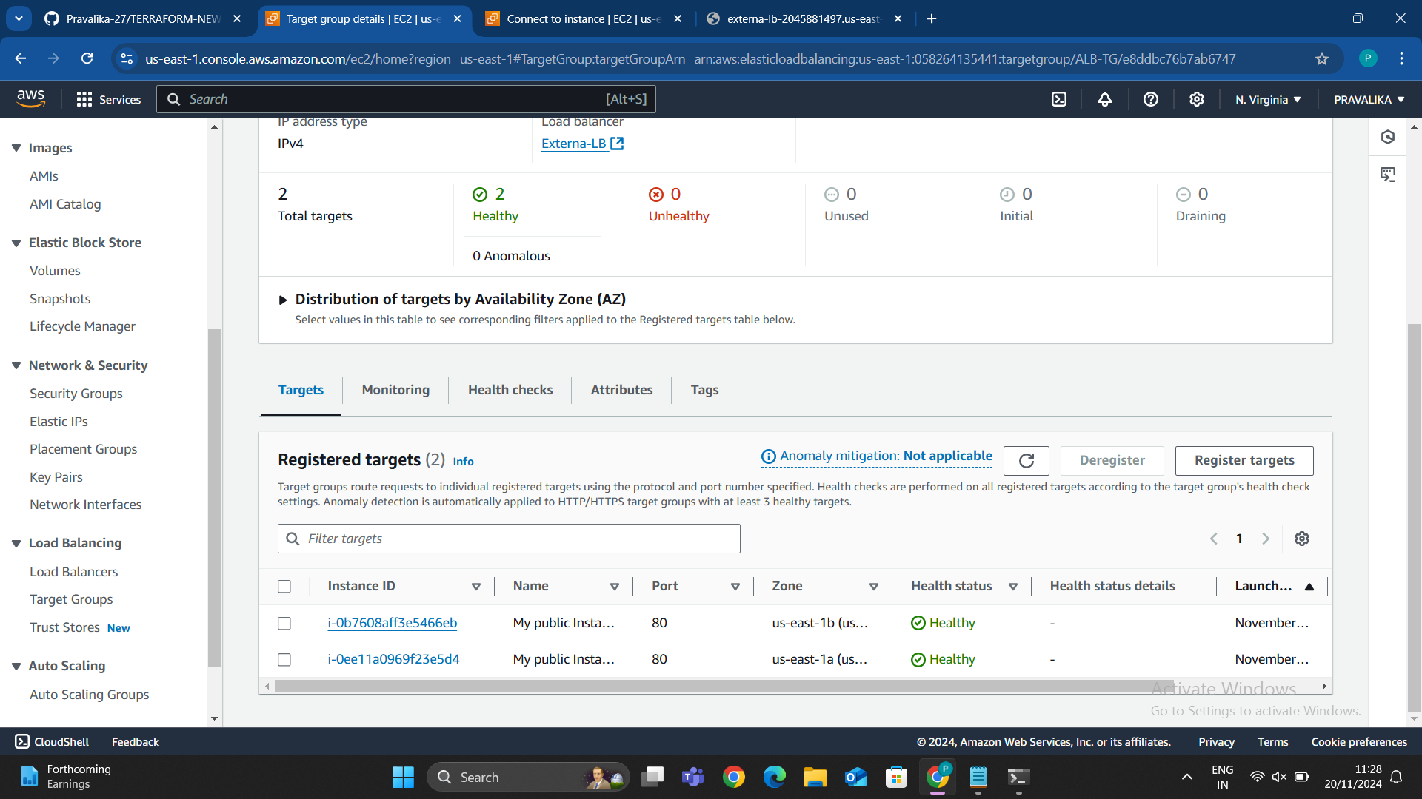

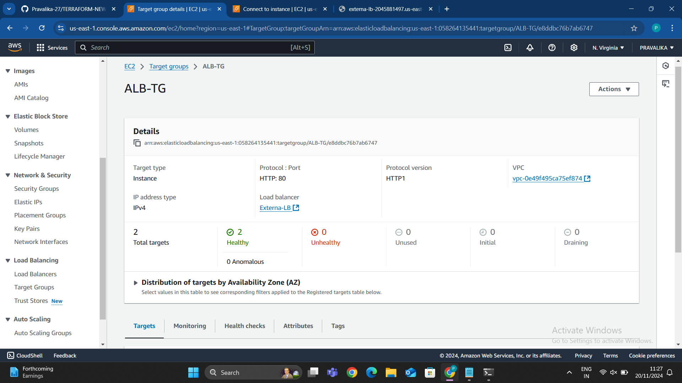

Copy the DNS of the load balancer and paste it in browser we can able to see the servers are working properly it will fluctuate the servers.

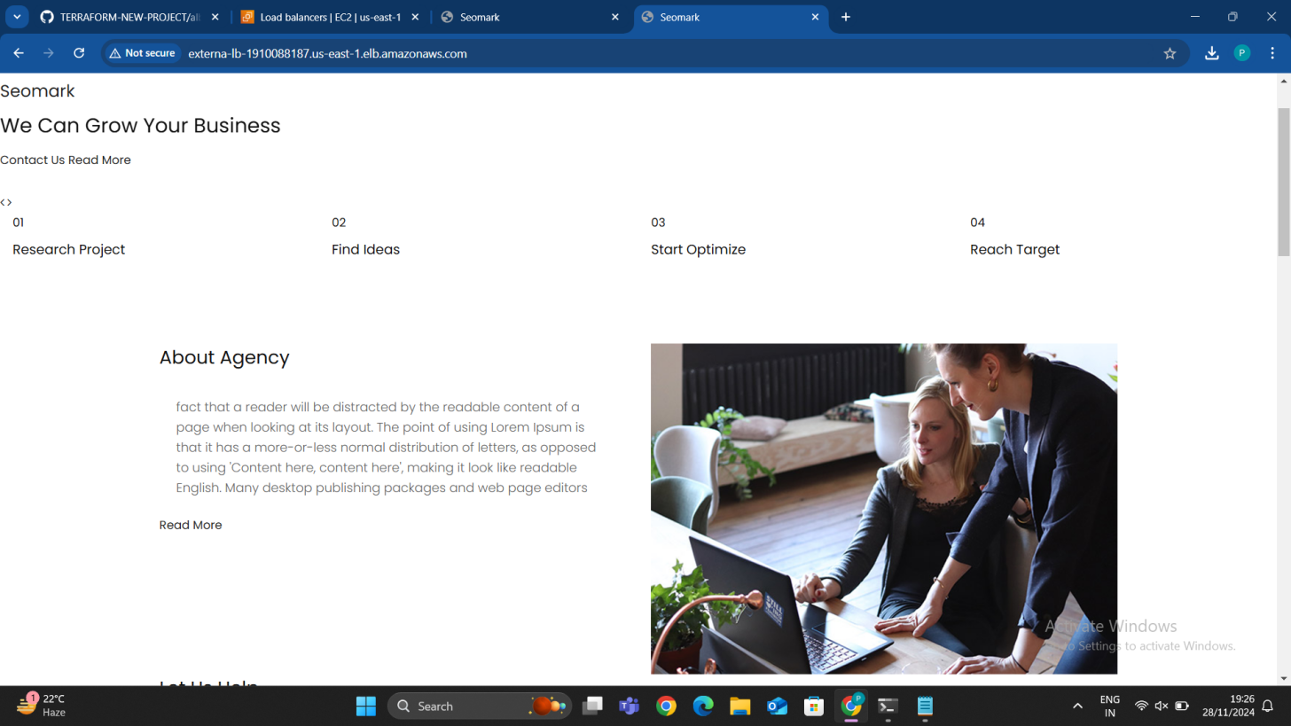

It shows the second server when I reload.

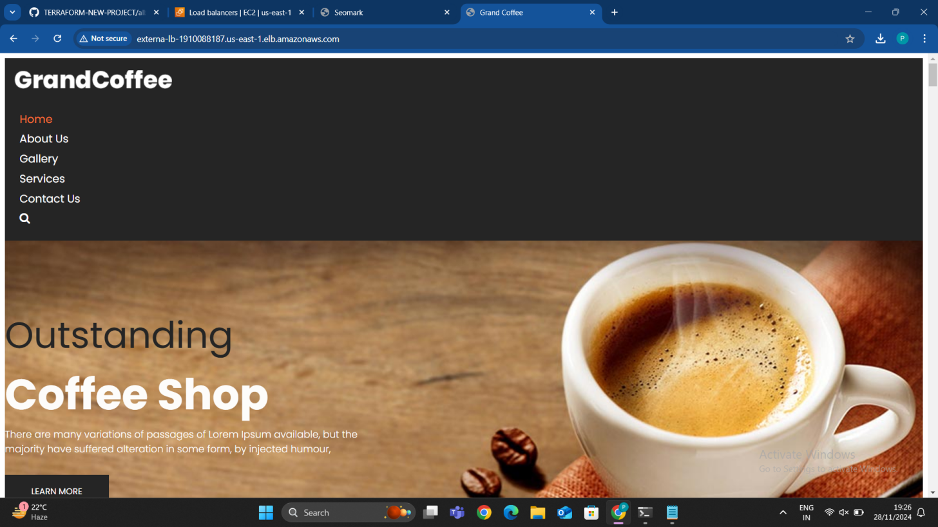

**STEP 11: CREATING A FILE FOR AN RDS INSTANCE**

Amazon RDS (Relational Database Service) is a managed database service by AWS that simplifies the setup, operation, and scaling of relational databases in the cloud. It supports various database engines, including **MySQL**, **PostgreSQL**, **MariaDB**, **Oracle**, **Microsoft SQL Server**, and **Amazon Aurora**.

The **rds.tf** file defines a managed database instance in AWS. It specifies the type of database, storage size, and networking rules. This setup ensures your database is secure and only accessible by the required application or resources.

### ****Key Features of Amazon RDS****

**Managed Service**:

* 1. Handles administrative tasks like backups, patching, monitoring, and hardware provisioning.

**Database Engines**:

* 1. Supports popular relational databases such as MySQL, PostgreSQL, MariaDB, Oracle, SQL Server, and Aurora.

**Automatic Backups**:

* 1. Provides point-in-time recovery with automated snapshots.

**Scalability**:

* 1. Easily scale storage and compute resources vertically (increase CPU, RAM, or disk size).
  2. Aurora offers horizontal scaling with read replicas.

**High Availability and Fault Tolerance**:

* 1. Multi-AZ (Availability Zone) deployments ensure high availability and disaster recovery.
  2. Automatically fails over to a standby replica in case of issues.

**Security**:

* 1. Supports encryption at rest and in transit (using SSL/TLS).
  2. Integrates with IAM, KMS, and security groups for fine-grained access control.

**Monitoring and Metrics**:

* 1. Provides performance insights and CloudWatch metrics for resource monitoring.

**Cost Optimization**:

* 1. Offers on-demand pricing or reserved instances for predictable workloads.

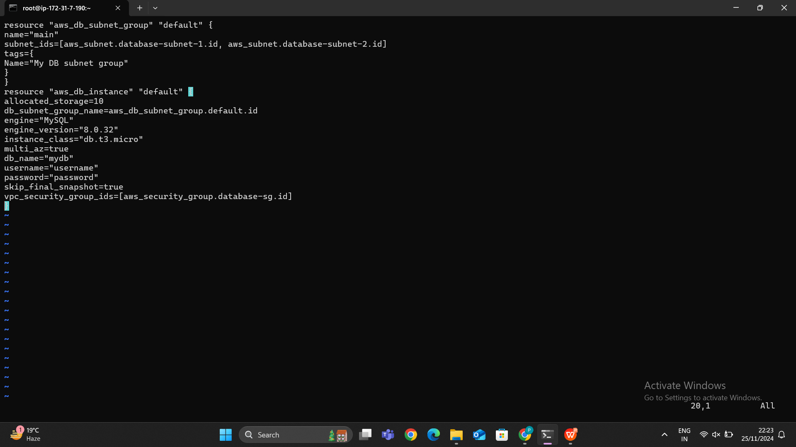

Then i have run the terraform plan command to check the configuration before creating an rds

Successfully created RDS.

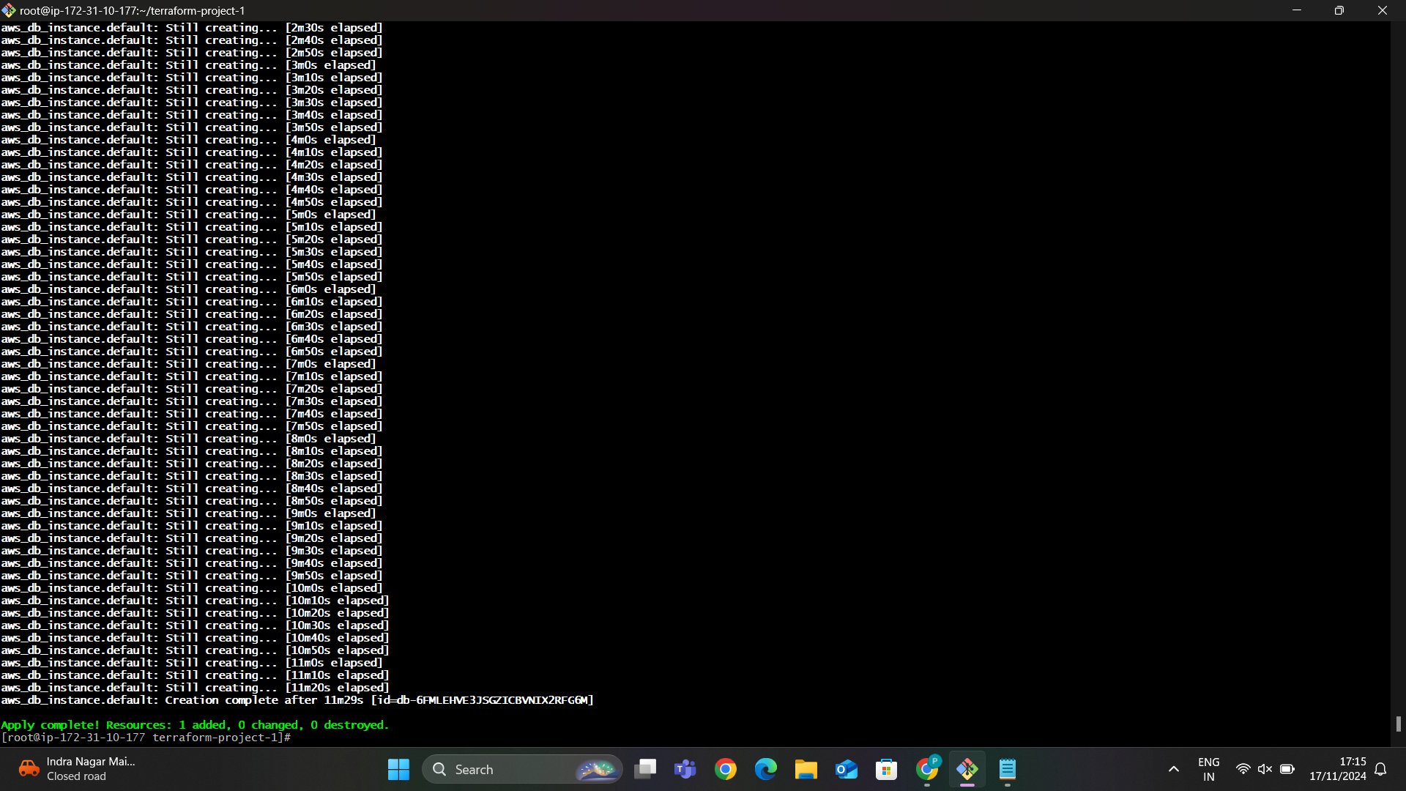

In the below image we can able to see that the database has been created successfully.

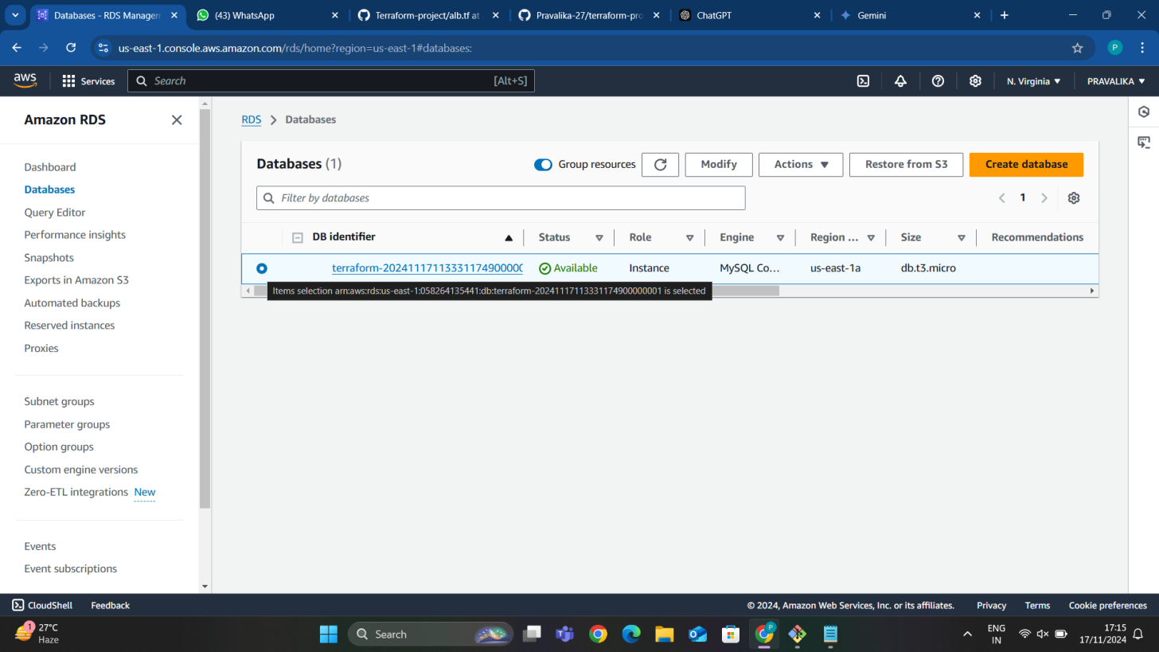

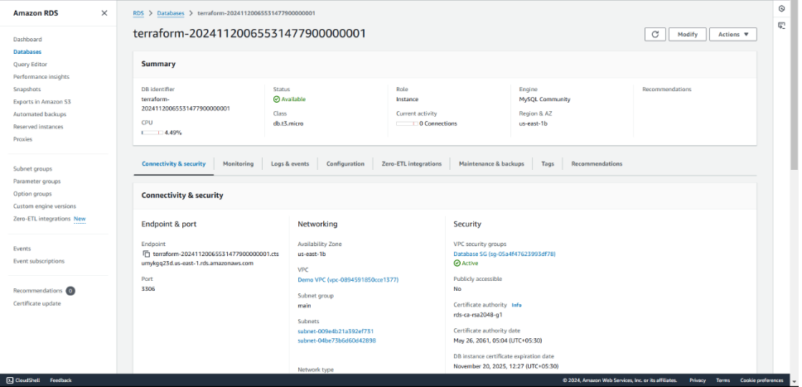

In the below image we can able to see that the configuration of the RDS.

**STEP 12: CREATING A FILE FOR OUTPUTS**

The **outputs.tf** file in Terraform is used to display the results of specific resources or attributes after applying the configuration. This helps users easily retrieve important information, such as instance IP addresses, database connection endpoints, or load blancer DNS names.

